Using enhanced and video podcasts of lecture recordings to support student learning: implementation and evaluation

Terese Bird, Sion Wyn Morris, Jesse Martin, James Brownbridge and Theresa Gill

School of Psychology, Bangor University, Bangor LL57 2UW, UK

Summary

The School of Psychology of Bangor University began using podcasts in teaching in semester two of the academic year 2005/06. Student feedback proved so positive, and the support burden proved so relatively minor, that a full implementation and evaluation project was undertaken beginning in January 2007. This work was supported by the Higher Education Academy Psychology Network Departmental Teaching Enhancement Scheme.

Some psychology lecturers for all years of undergraduate and masters study agreed to allow their lectures to be audio-recorded and the resulting files distributed to students in their modules. Several lecturers progressed to allowing both video and audio recordings, and the resulting movie files similarly distributed. Certain lecturers began to individually create their own podcast movie files for particular (usually skills-based) teaching. From a support point of view, emphasis was placed on finding the simplest and most systematic method of recording and distribution, so that students could depend on both quantity and quality and staff could experience as little burden as possible. Finding the smartest solutions for the lowest cost was key. Students then evaluated the use of podcasts in their usual end-of-term module feedback, as well as via a special online survey done for this study. Staff evaluated the use of podcasts via personal discussions as well as via a special online survey done for this study. Podcast file download rates were also considered. This report summarises the main findings of our study.

Background

The advent of the podcast has not marked the first recording of university lectures. In 1994, Roberts (1994) reported on students’ use of analog audio recordings of lectures. He found that students who made such recordings asked staff fewer questions outside of class and also did not deliberately miss lectures. Barringer and Bekiroglu (1978) found that graduate students with access to recorded lectures achieved higher marks. Bangor Psychology utilised videotaped statistics lectures to overcome official timetable conflicts as far back as 1997. Students who could not attend lectures were given the videotapes to watch at home or in the department. The kinds of difficulties experienced at the time included the camera operator not anticipating when the lecturer was going to begin pointing to an image displayed by an OHP.

The podcast, however, has made a unique impact on higher education. While cassette recorders and VHS camcorders were generally too unwieldy for personal recording, and recordings made were not easily copied or distributed, podcasts are by definition distributed anywhere in the world via the internet, equipment for recording them is either very compact and/or easily set up in a teaching space, and the actual work of recording does not require realtime human intervention. Furthermore, podcast “receptacles” – mobile phones, mp3 players and personal computers--- were already widely owned for other uses, and often personally carried. Thus the stage was set for a multimedia mini-revolution in higher education.

One of the first major podcast experiments in higher education took place when Duke University distributed Apple iPods with voice-recording attachments to over 1600 entering first-year students in August 2004 (Belanger, 2005). While there were difficulties reported with the use of the iPods in learning, benefits included the ease and personal controllability of revising lecture content and group discussions, independent access to multimedia course materials anytime and anywhere, and enhanced support for individual learning needs and preferences.

At Bangor University Psychology, interest in podcasts began as a way of providing additional support for students with special needs. The Dyslexia Unit (independent research unit within the School of Psychology) had previously arranged for mp3 recordings of lectures to be made and given to students with dyslexia. When the mp3 recorder installed in the lecture theatre got stolen for the second time and the central IT department decided not to record any longer, Psychology’s own tech support got involved. In January 2006, we discovered that an inexpensive piece of (Macintosh-only) software could be installed on the computer already present in the lecture theatre, and scheduled to make mp3 recordings. The software is WireTap Pro (now WireTap Studio, from Ambrosia Software for $69.00). The only additional thing to do was to input the lecturer’s microphone signal into the computer running WireTap Pro. The resulting files were distributed to special-needs students via a special module on Blackboard. Suddenly, at a cost of less than 40 pounds, we were automatically recording and easily distributing Psychology lecture podcasts. A press release from that time can still be read online at NewsWales.co.uk (NewsWales, 2006). One student is quoted in this article, “No matter how hard you concentrate in lectures you never take it all in… and for the last few weeks the only thing I have been listening to on my iPod is neuropsychology lectures!”

Initial attempts at recording statistics-skills training movie podcasts were then made. Using Snapz Pro (also Mac-only, from Ambrosia Software for $69.00) to make these movies was a low-cost and simple method. The instructor demonstrated statistical methods on a computer using SPSS, Excel or other programmes, explaining as he went through the steps. Using Snapz Pro, everything visible on the computer monitor as well as everything he said was captured and married together as a Quicktime movie. This was initially done live, capturing skills taught in scheduled computer lab sessions. The instructor distributed the movie files using Blackboard. It was immediately clear that students found it very helpful to follow these movies, step-by-step, on the same computer on which they were working with SPSS. Students could effectively “rewind the instructor,” and go over the same step until they fully understood it, not being rushed on to the next step before they were ready.

Some benefits in using podcasts were fairly clear, then, at the commencement of the project. The stated objective of the project was to evaluate the value and challenges of using podcasts, enhanced podcasts and vodcasts of lectures to support student learning. In particular, the project aimed to:
- Provide students with podcasts, enhanced podcasts and vodcasts of lectures, to support reflection and further learning following lectures, including revision;
- Support staff in producing podcasts, enhanced podcasts and vodcasts of lectures;
- Provide an infrastructure to facilitate the production and provision of podcasts, enhanced podcasts and vodcasts;
- Evaluate the impact of this provision on the student learning experience;
- Compare different methods of podcast recording, production and distribution;
- Evaluate technical issues in the provision of podcasts;
- Make recommendations to the Department and the University as to the desirability of providing podcasts more widely and, if relevant, recommendations as to particular technical issues associated with extending such provision.

What is a podcast?

Colloquial use of the term podcast extends to any sound file, or any sound-and-video file. However, a true podcast is a series of digital media files distributed over the internet or an intranet via a syndication feed, such as in the format of RSS. This allows users to “subscribe” to a podcast, using “aggregator” software such as iTunes or Juice (both of which are free and available for both Macs and Windows). After subscribing, all “episodes” of the podcast are clearly visible and easily selected for download. Aggregators keep podcasts well-organised, as figure 1 shows:

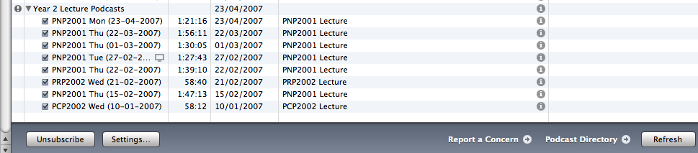
Fig 1. Closeup view of a single podcast (Bangor Year 2 Lecture Podcast), consisting of 8 episodes, the fourth of which is a movie. The podcast is displayed in iTunes.

iTunes is most often associated with the Apple iTunes Store, the online service by which music and other media can be purchased. However, the iTunes software will display podcasts on any server which is correctly set up to display them; in this case the podcasts have nothing to do with the iTunes Store and the files do not reside with Apple. This is how we set up our server; iTunes software displays our podcasts to any iTunes client anywhere in the world. The Apple website gives detailed instructions for setting up a server so that it will display and serve podcasts correctly (Apple).

When we first offered podcasts to students, they were technically not podcasts, but only sound and movie files downloadable from a VLE. We then set up our server with the RSS feed that enabled podcasts. At first we continued to use our VLE as the doorway to the podcast listing (see Figures 2 through 4).
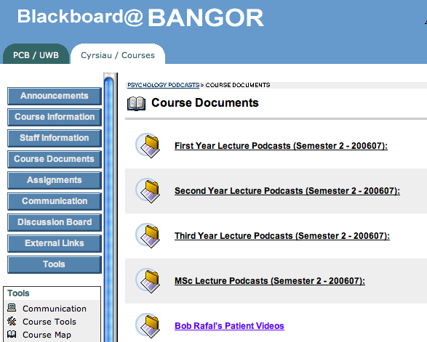
Fig. 2. “Psychology Podcast” module in Blackboard. All psychology students were enrolled on this module. Clicking onto First Year Lecture Podcasts yielded Figure 3.

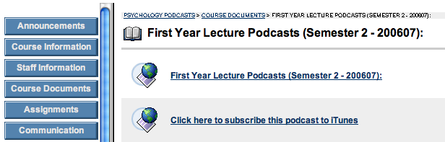
Fig.3. Within each year of study, students could choose from viewing a list of available recordings (see Figure 4) or could subscribe to iTunes and view the same recordings by that method (such as in Figure 1).

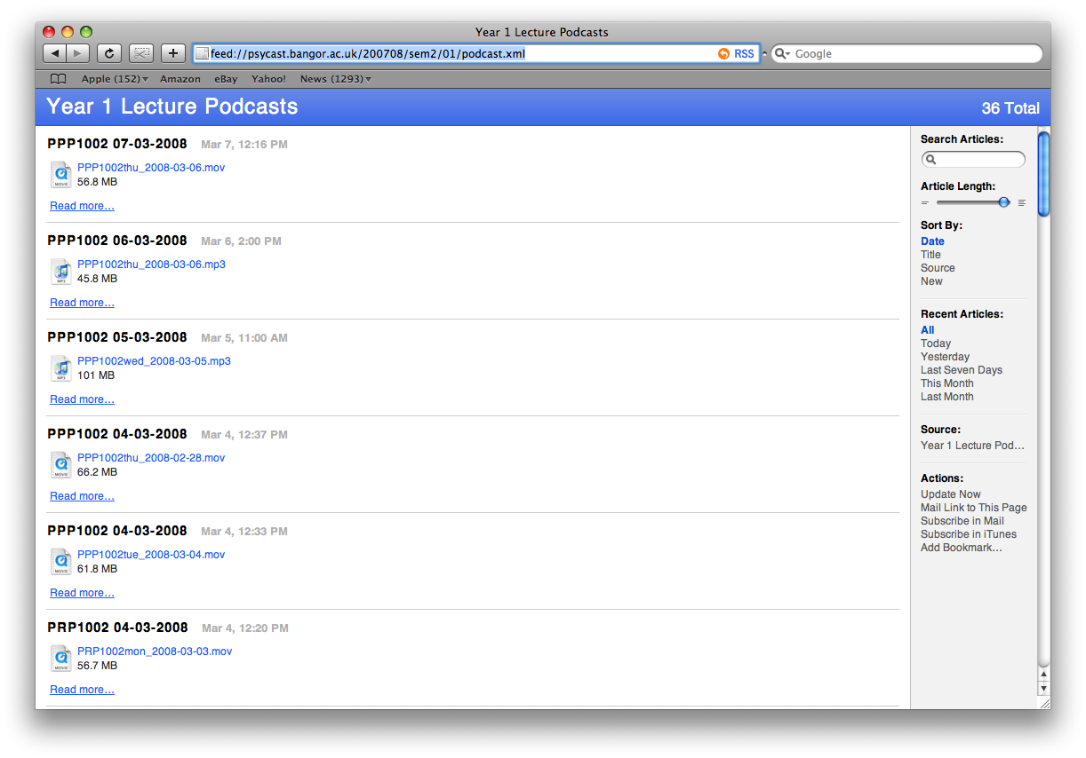
Fig.4. Safari browser displaying the Year 1 Lecture Podcast, via an xml file.

Beginning in autumn 2007, rather than using Blackboard, we configured our own departmental intranet page to both display the podcasts and to offer the choice to subscribe using iTunes (see Figure 5).
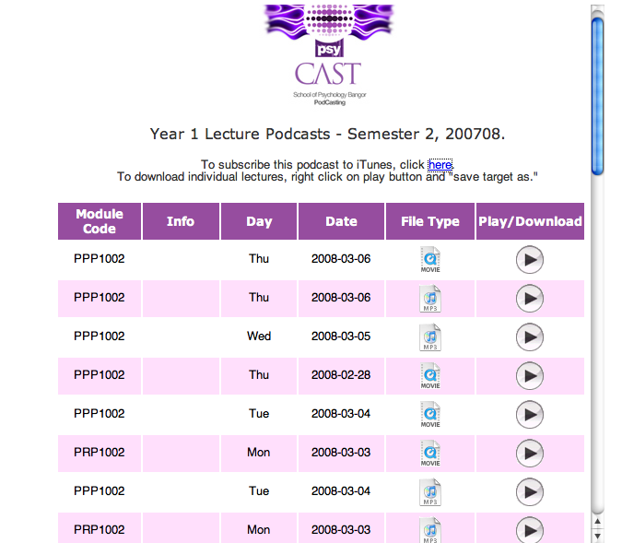
Fig.5. Psychology student intranet website, displaying Year 1 lecture podcast, as well as the choice to subscribe to the podcast via iTunes.

Why podcasts?

iTunes supports sound files of type .mp3 and .m4a, movie files of type .mov, .m4v and .mp4, and .pdf files (which are picture files) . These were therefore the file types we standardised upon. Why standardise movie files of type .mov and .m4b, when Windows computers are pre-configured to read Windows Media Player (.wmv) files? Why not just use the Microsoft Powerpoint feature which allows a presentation file to run by itself with recorded narration? Or why not use Flash, and let the movie play in a browser like so many Flash movies? These questions warrant answers, as they help to illustrate what is uniquely useful about true podcasts. What is it about podcasts that separates them from so many other computer-based learning aids from the past?

- Podcasts are downloadable. The files actually come to live on the recipient’s computer or other device. Therefore the files can be played even if there is no current network connection (unlike Flash movies which tend to require a current internet connection in order to play). Therefore, students could bring mp3 players or mobile phones to the university computer lab and make use of the fast university network to download all the files on their mp3 player or phone. Students could bring personal laptops to a university building with wireless networking (a university wi-fi hotspot), and could make use of the fast university network to download files onto the laptop, then go back home where the network may be slow or nonexistent but they would still have access to needed podcasts.
- Podcasts are portable. Students can listen, via mp3 players, to lectures while they are walking or driving. If they own a video mp3 player, students can watch movie files whilst on the train or otherwise away from a computer or network. A Powerpoint show (with or without narration) cannot be natively played on mobile phones or mp3 players.
- Podcasts are free to the consumer and the software which plays them is free. iTunes, Quicktime, and Adobe Acrobat Reader are all cross-platform and free. Microsoft Office, even when purchased at educational discount, is far from free.
- Presentations saved as podcasts are better protected than in their original format. Powerpoint files, if distributed as originally saved, can be changed and pictures and movies can be “stolen” out of them. But when a Powerpoint presentation is recorded as a podcast, it is not at all easy to steal media or change the file. Similarly, a Word file saved as a pdf so that it can be viewed in an aggregator is protected in that the format cannot be changed.
- Podcast files are efficient. An mp3 recording of the same sound will always be a much smaller file than a .wav file. Also, aggregator software is very efficient in the way it subscribes, downloads, and updates podcast episodes.
- Since podcasts are distributed via the internet or an intranet, they easily reach a large audience anywhere, anytime.
- Since podcasts use a web feed format, many different podcasts and episodes can be served simply by making sure the feed is formatted correctly.
- Since podcasts use a web feed format, numerous episodes can be kept well organised, for students to see which they have not yet received, which they may wish to skip, and new podcasts to which they may wish to subscribe.

It is notable that all of the file types supported by iTunes are also supported by other software; for example, RealPlayer and VLC both play .mov movies. Windows Media Player files, in contrast, can only be played by Windows Media Player.

It is also notable that not all of the sound and movie files we have produced have been distributed via an RSS feed, and thus are not technically podcasts. Regardless, sound and movie learning materials can be easily made and are useful to students even if they are not technically podcasts.

Some clarification is called for regarding different kinds of podcasts we created:

- Sound-only podcasts were made of live lectures and saved/distributed as mp3 files. Software used: Audacity (free from http://audacity.sourceforge.net/) for both Macs and Windows; for pre-scheduled sound-only recordings, we used WireTap Pro for Macs and TotalRecorder for Windows.
- Enhanced podcasts consist of a sound file married together with still images, one after another. We used ProfCast on Macs. This software is Mac-only and only works with Powerpoint or Keynote.
- Vodcasts are video podcasts, consisting of a sound file married together with video. We created vodcasts with specialist software (Snapz Pro on Macs, Camtasia on Windows) at first. Later we developed a method by which everything displayed through the demonstrator projector was captured as a movie and married together with the lecturer’s voice, and saved as a .mov movie file.

Our progress through the various podcast types was as follows:

1) We made sound-only podcasts of all instructors who wished to have recordings made. We did this by the automated method of recording, saving to the server, and distributing over the internet, described in the next section. This was done from January 2006 to the present.
2) One instructor in statistics began in January 2006 to individually record statistics instruction movies, using Snapz Pro. These were our first vodcasts.
3) Some instructors were interested in making enhanced podcasts of their own lectures – in other words, they wished to capture the Powerpoint slides along with their voices. Beginning in Autumn term 2006, some lecturers did this by using ProfCast on Macs and Camtasia on Windows.
4) By the beginning of 2007, we began to look into automatically creating vodcasts of lectures, in such a way that the instructor would not have to do anything except lecture while the vodcast recorded. This led to the creation of The VodBox, our own automatic vodcast maker. A recipe for the VodBox is given later in this report.

Sound-Only Podcast Implementation Method

The following is a breakdown of how sound-only podcasts were automatically recorded and served.

Server: We purchased a new Apple Xserve server to be the podcast server. It is not necessary to use a new server nor an Apple server to be a podcast server. All that is really needed is a server which can host webpages.

In Lecture Theatres: In lecture theatres which had Mac computers installed as the demonstrator computer, WireTap Pro was installed and the feed from the sound system was connected into the Mac. Lecture timeslots for those lecturers who wished to podcast were scheduled into iCal (native Mac calendaring programme) so WireTap Pro would “know” when to launch and record. Recorded files were automatically saved into a certain shared folder on the Mac. In lecture theatres which had Windows computers installed, TotalRecorder (http://www.highcriteria.com/) was used in the same way that WireTap Pro was used. Both programmes were set to automatically name resulting files after the date/time of session.

Files on the Server: A shell script (see Figure 6), written by our technician, ran regularly on the server. It mounted the shared folder of each lecture theatre Mac, compared contents of the folder, copied to the server any new files, and finally generated a new xml file, holding updated information (we did not set up automatic copying of files from Windows computers in lecture theatres, although we could have done and may do in future):

#!/bin/sh
if `rsync -av podcast@<insert here the IP address of the lecture theatre computer>:/Users/podcast/Podcast/* /Users/sysadmin/Desktop/Received/` ; then
echo "PJ Hall offline"
fi
if `rsync -av podcast@<insert here the IP address of another lecture theatre computer>:/Users/podcast/Podcast/* /Users/sysadmin/Desktop/Received/` ; then
echo "Wheldon 1 offline"
fi
… and so on through all of the lecture theatre computers…

python /Library/Scripts/podcastScripts/xmlGenerator.py
exit
Fig.6. Shell script which copies sound recordings from lecture theatre computers to the server, then calls another script which generates the xml

The xmlGenerator script is included as Appendix 1. The resulting xml file is readable by any modern browser. An example of how the browser Safari displays an xml file is in Figure 4. We simply put a link to the xml file on our server, on Blackboard: http://psycast.bangor.ac.uk/200607/sem2/1/podcast.html. When students clicked the link, they would see a page such as in Figure 4. We also put on Blackboard the iTunes link: itpc://psycast.bangor.ac.uk/200607/sem2/1/podcast.xml. When that link was clicked, iTunes would launch and the podcast would download into iTunes.

Non-automatic Podcast Recording: There were some classrooms in which, due to time or resource constraints, automatic podcast recording could not be set up. The most successful method of providing podcasts from such rooms was to issue to the lecturer or to a student in the class a personal mp3 recording device. The model we used was Olympus. These devices recorded files in .wav format. We used Switch on a Mac ($30 from http://www.nch.com.au/switch/plus.html) to convert these files to .mp3. Files were then named according to the naming convention required by the server, and copied to the correct place on the server.

Instructor-Created Enhanced Podcast and Vodcast Implementation Method

Lecturers using a Mac to demonstrate in the lecture installed ProfCast ($29.95 education price from http://www.profcast.com/public/index.php) in order to create an enhanced podcast. ProfCast very simply saves all pictures from a Powerpoint of Keynote presentation, marries together with the lecturer’s narration, and saves as a .mov file. Limitations of this method included the fact that ProfCast could only record Powerpoint or Keynote ---- it could not record extra movie clips that the lecturer would show nor SPSS demonstrations. Also, ProfCast took quite a long time to process at the conclusion of the lecture. If this processing was being done on the regular lecture theatre computer, problems arose when the next lecture needed to begin but the machine was tied up by processing. Also, ProfCast, for all its simplicity, was still something the lecturer had to do. It became clear that we should figure out a way to take this burden from the lecturer.

Lecturers using a Windows computer to demonstrate in lectures used Camtasia ($89.50 education price from http://www.techsmith.com/camtasia.asp). We first attempted to use ViewLet Cam (education price $139 from http://www.qarbon.com/store2/edu.php) but ViewLet Cam saved files as Flash or avi. Neither of these file formats are very good for portability. Flash was not bad, but students complained that they could not control the Flash movie --- they could not stop it or rewind it. So we switched to Camtasia which saves directly as a .mov and is very easy to use.

When lecturers brought their own laptops to the lecture theatre and wished to use the laptop to record the vodcast, we sometimes had an issue with sound ---- how to pick up a good quality recording of their voice whilst not having to fiddle with the lecture theatre’s sound system right before the lecture. The answer was to purchase a bluetooth microphone (Plantronics) which the lecturer could wear round his neck and plug the receiver bit into the laptop. In our case, the lecturer had to wear both the bluetooth microphone, which fed the vodcast, and the conventional radio microphone in order for his voice to come out of the speakers in the room. This worked well and solved the problem. Vodcasts recorded in these ways by the lecturer were not automatically copied to the podcast server. Lecturers or support staff simply named the files according to the convention required by the RSS feed system, and saved them directly onto the server.

Automatically-Recorded Vodcast Implementation Method (Vodbox Recipe)

It was decided to pursue a vodcast-recording-and-distribution method which was as automatic as the method developed for sound-only podcasts. Requirements were: neither the lecturer nor the lecturer’s computer should bear the burden of recording, and everything displayed out of the projector should be captured regardless of software or operating system of demonstrator computer. While pursuing a possibility which would have employed a Linux computer, it was finally decided to use a Mac Mini fitted with a VGA to USB hardware device (“VGA2USB” for $299.95 from Epiphan Systems, http://www.epiphan.com/products/product.php?catid=1&gclid=CK_ooYyRupICFQOc1AodjimpcA) which would first feed the signal meant for the projector into the Mac Mini. A programme running on the Mini, SecuritySpy (£28.00 from http://www.securityspy.com) records the video-and-audio signal, compressing it to an mpeg4 movie, saved into the shared folder of the Mac Mini, ready to be copied onto the podcast server.
Lecturer
Computer running
Powerpoint or any software
VGA Splitter (included with VGA2USB)

VGA2USB
USB cable

Mac Mini Running
SecuritySpy
Software. Files saved into shared folder

Projector displays image onto screen as usual

Fig.7. Diagram depiction of VodBox components and operation

Price List for VodBox

Mac Mini education price £359.55
VGA2USB 150.00
SecuritySpy 28.00
-----------------------

TOTAL: £537.55
We started by building two VodBoxes and installing them in our two heaviest-used lecture theatres. The results proved so positive that we were able to convince our central IT services to purchase the next two, on the promise that we would record vodcasts for other departments who might use those lecture theatres.

The main benefit of the VodBox is the automatic recording of vodcasts at a very low price. We are not aware of any other system which can do so much for such a small price tag, and which can be put together without a great deal of specialist technical knowledge.

Podcast Download Numbers

Blackboard tracked podcast downloads during academic year 200607, but imperfectly. Podcasts downloaded directly through Blackboard were correctly tracked, but podcasts downloaded through Blackboard and then through iTunes yielded figures which require further interpretation.
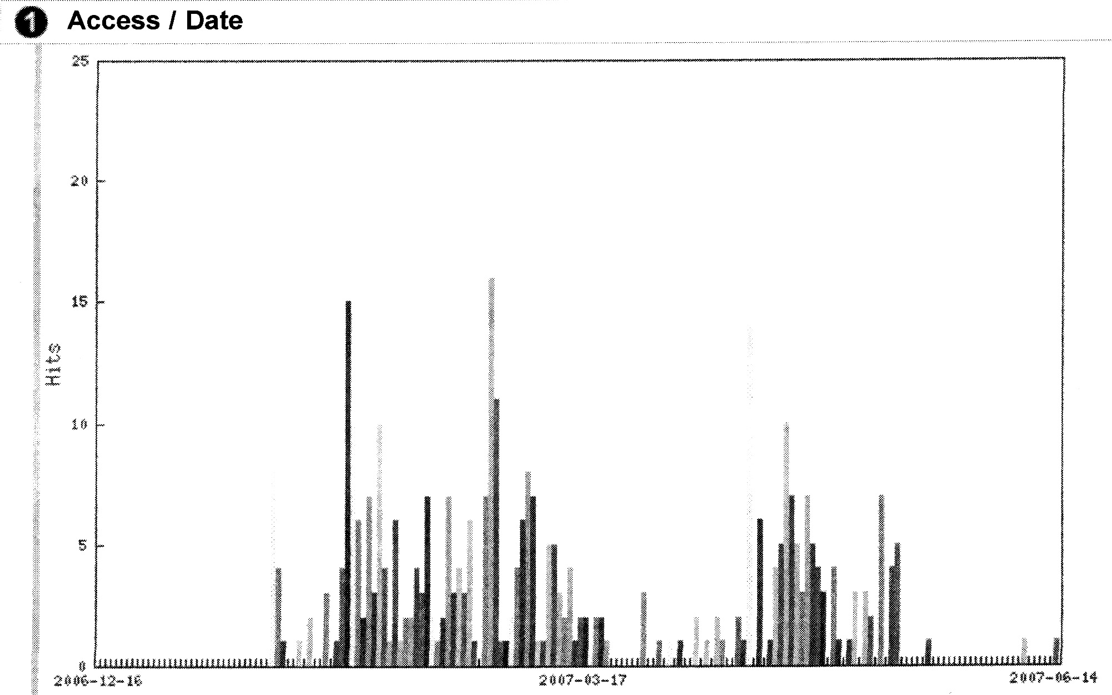
Fig.8. Year 1 (sem 2 2006-07) two modules only, Blackboard-only, podcast downloads from 16 December, 2006 through 14 June, 2007. TOTAL: 353
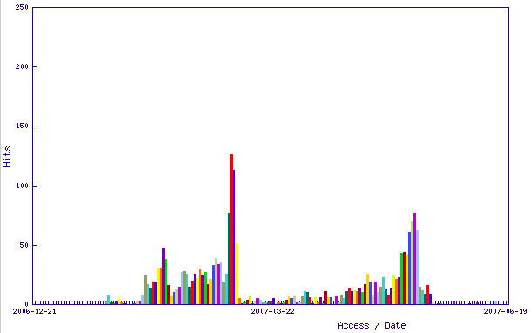Fig.9. Year 2 (sem 2 2006-07) four modules, Blackboard-only, podcast downloads from 21 December, 2006 through 19 June, 2007. TOTAL: 2297
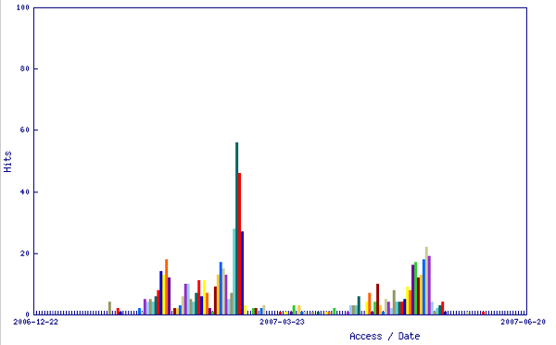 Fig.10. Year 2 (sem 2 2006-07) four modules, iTunes podcast downloads from 16 December, 2006 through 14 June, 2007. TOTAL: 684
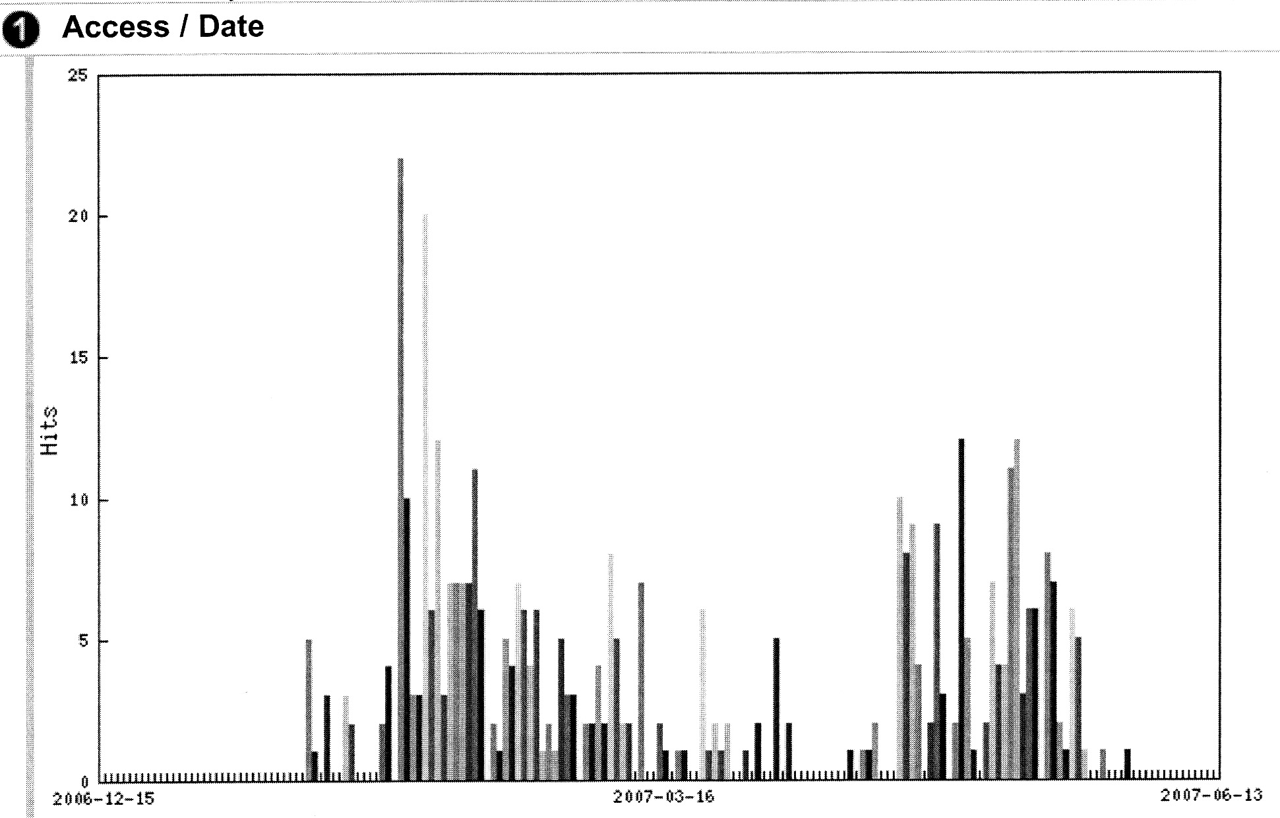
Fig.11. Year 3 (sem 2 2006-07) two modules only, Blackboard-only, podcast downloads from 16 December, 2006 through 14 June, 2007. TOTAL: 447.

Discussion begins with Year 2, as we have both the iTunes and the Blackboard-only download rates for year 2 (iTunes download rates were initially recorded, but the stats were ultimately not available for years 1 or 3 due to a problem with Blackboard). All of the lecturers in four modules within year 2 that semester wanted to try podcasting; one recorded his own lectures as vodcasts. Each of the four modules was fairly heavy, likely to have new terminology, and exams and assignments were strongly based on lecture material. These factors contribute to the high download figures.

A “hit” in the Figure 10 scenario registered each time a student clicked on the place in Blackboard which led to the iTunes listing for year2 podcasts. Once in iTunes, the student downloaded any lectures waiting for him/her since the last time iTunes was visited. From discussions with students, we found it was likely they visited iTunes perhaps once a week. It would be reasonable, perhaps even conservative, to estimate that for each iTunes “hit,” a total of four individual episodes was downloaded, on average. Therefore, 684 “iTunes hits” on Figure 10 likely means 2736 episodes downloaded. Add that to 2297 direct Blackboard downloads, and we see that second year students likely downloaded 5033 podcast episodes in semester 2 of academic year 2006-07. And of course, there is no way to tell how many times the student listened to or viewed each episode once it was downloaded.

Year 1 download numbers do not look very spectacular, with highs of 15 and 16 downloads on days in mid-February and early March. Only two modules were offering podcasts, one of which featured lectures that were not central to the assessments. It is also estimated that the total of 353 should at least be doubled, to account for iTunes downloads.

Year 3 download numbers are interesting in that they represent podcasts of two modules, but one of these modules was simultaneously offering podcasts by yet another method (unbeknownst to the podcast technicians). Therefore Figure 11 can be said to represent Blackboard-only downloads for 1.5 modules. To account for the iTunes method and the third method in this module’s case, It would be fair to guess that the number 447 should be tripled to give a more accurate estimate of episodes downloaded by students in those two modules: 1341.

These semester-wide download patterns suggest that students download podcasts which they perceive will support their assessments --- one need only look at the graphs to guess what dates Bangor Psychology students were sitting midterms and final exams. The years 2 and 3 data suggest that students engaged in multiple-downloading --- once they downloaded one lecture, they came back to download more lectures of the same module. Listening to lecture podcasts became a habit.

SPSS Vodcast Download Patterns

In semester 1 of academic year 2007-08, Year 1 Research Methods was taught in such a way that vodcasts were regularly distributed (via Blackboard), and students were regularly quizzed on the contents of the vodcasts (among other content). Seven vodcasts were posted, and stats were gathered on their download numbers between 1 September 2007 and 31 January 2008:

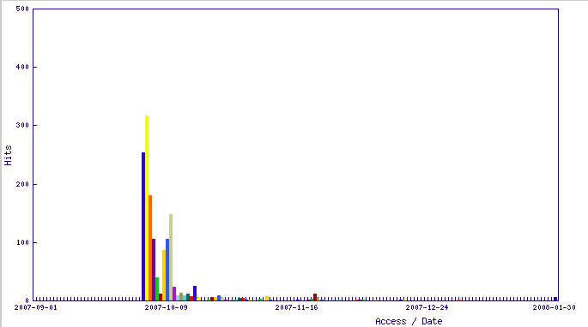
Fig.12. Week 1. TOTAL: 1447
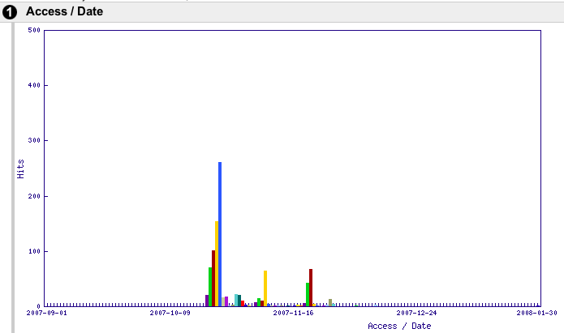
Fig.13. Week 4a. TOTAL: 960
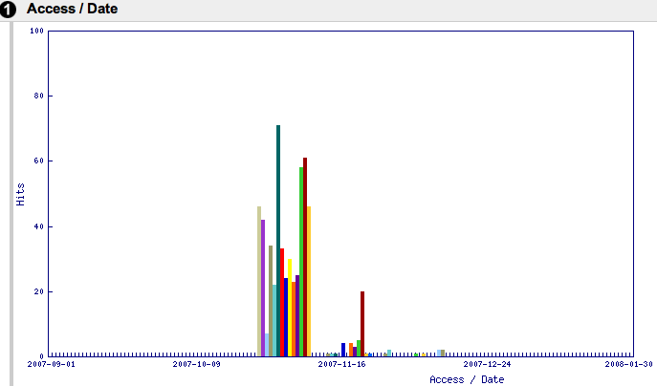
Fig.14. Week 4b. TOTAL: 572
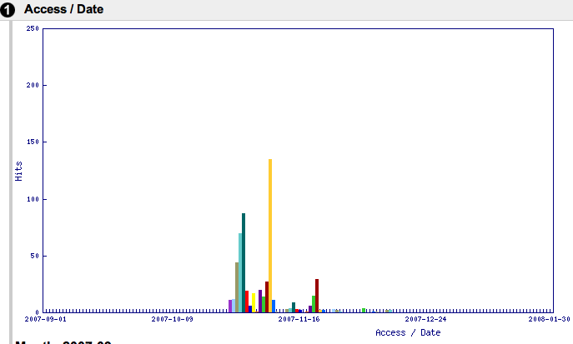
Fig.15. Week 5. TOTAL: 567
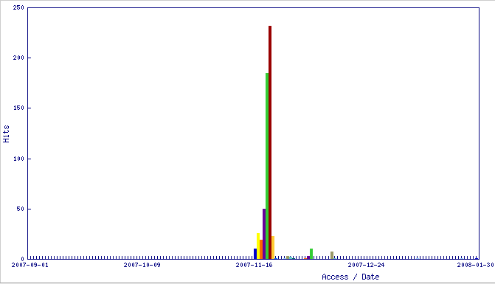
Fig.16. Week 8. TOTAL: 578
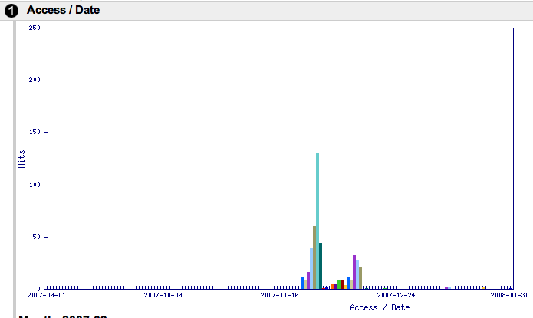
Fig.17. Week 9 TOTAL: 453
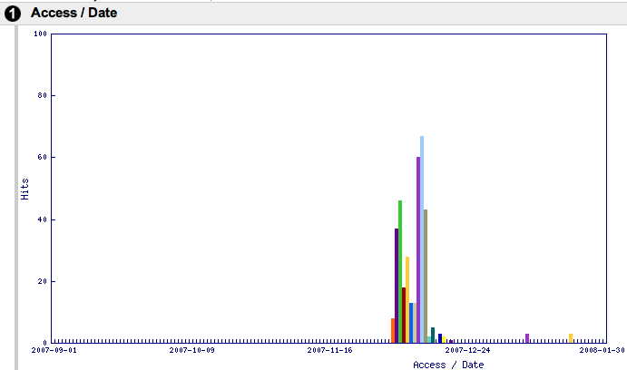
Fig.18. Week 10. TOTAL: 352

One can see that students heavily watched the vodcasts to learn material on which they would be assessed. In this case, after the quiz, students did not return to the material. It can also be seen that students watched the vodcasts more often earlier in the term. A look at the breakdown of what days of the week students tended to view these vodcasts (in Figure 19) reveals what day of the week quizzes were sat (choosing Week 5 as a representative sample):
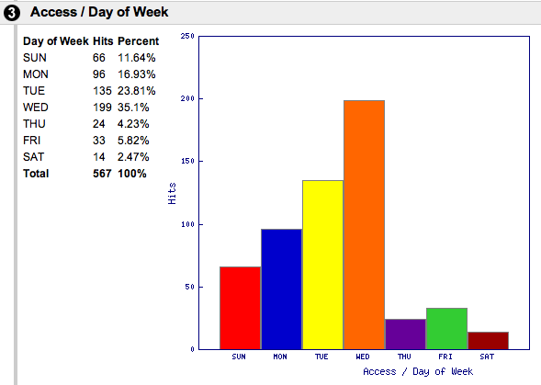
Fig.19. Week 5 “days of the week on which students viewed vodcasts”
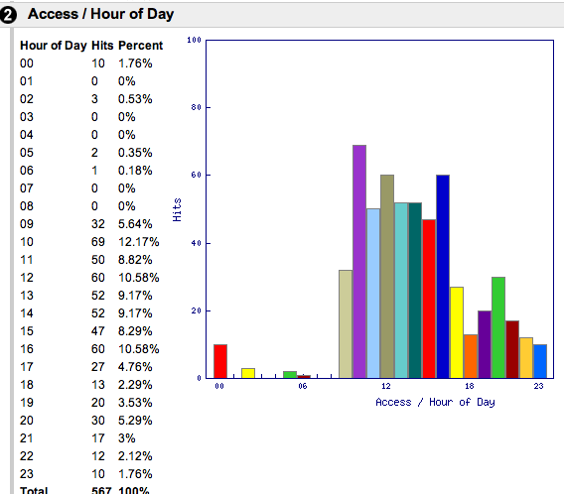
Weekly quizzes were administered on Thursday mornings. At what hours of the day did students view vodcasts? Looking again at Week 5:

Fig.20. Week 5 podcast access by hour of the day. Only during some of the very early morning hours were there no downloads. Students make use of access anytime.

The charts in Figure 21 show downloads for Research Methods year 2 semester 2 2007-08 for SPSS vodcasts in which each consecutive vodcast teaches the next step in a long procedural assignment which is due in week 10 of the semester. Chart snapshots were taken during week 8. Students are working with these vodcasts steadily throughout the weeks. (Charts progress left to right, then down.)
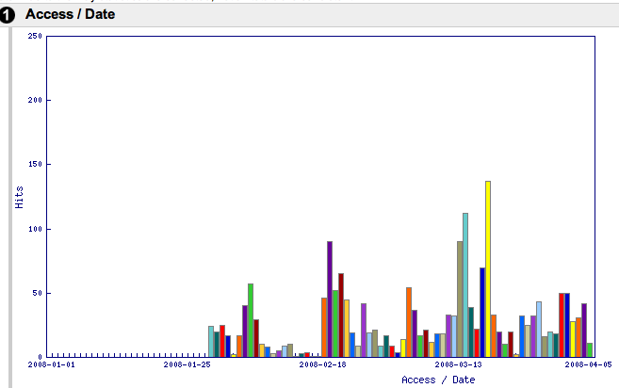  StStep 1  Step 1 | 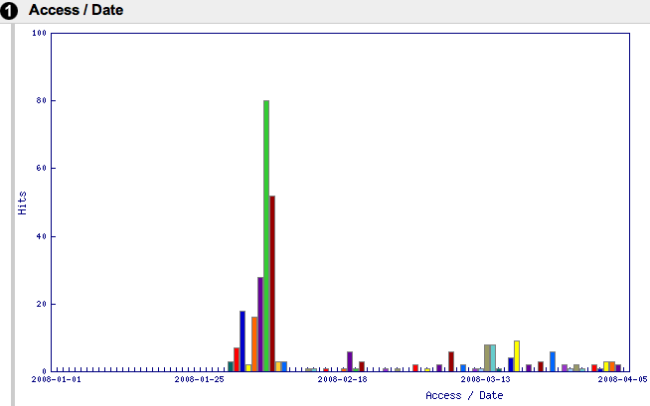  Step 2
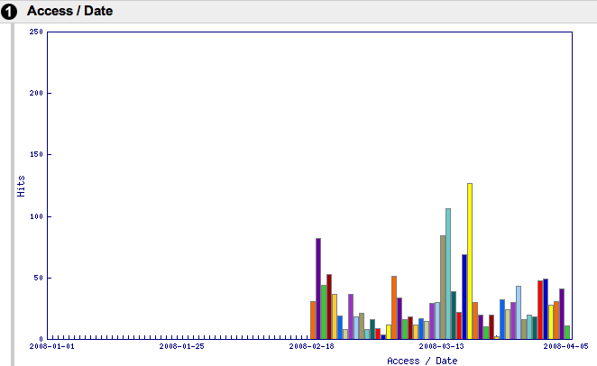  Step 3 | 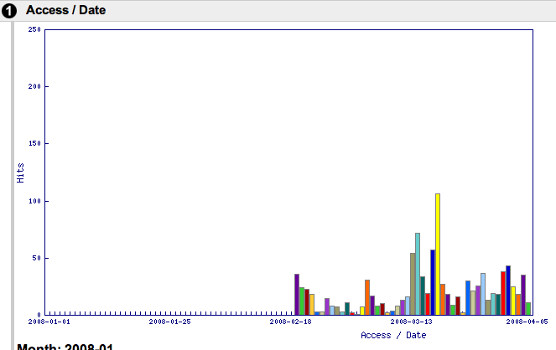  Step 4
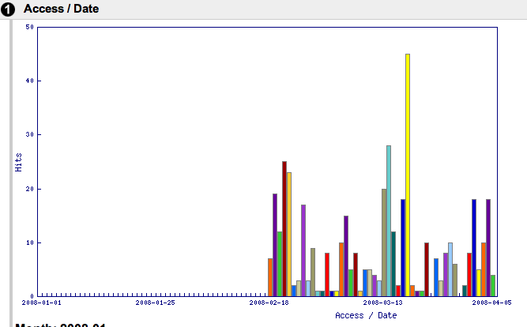  Step 5 | 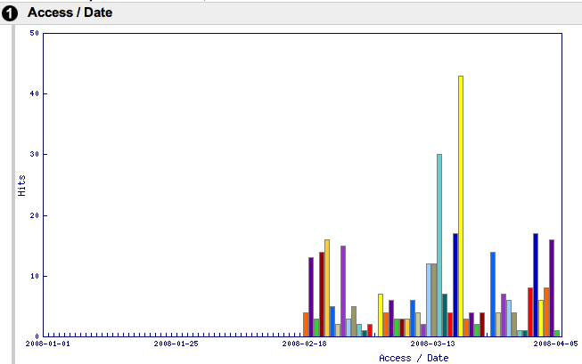  Step 6
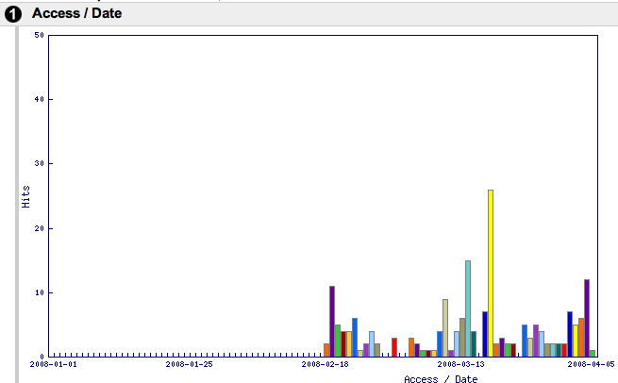  Step 7 | 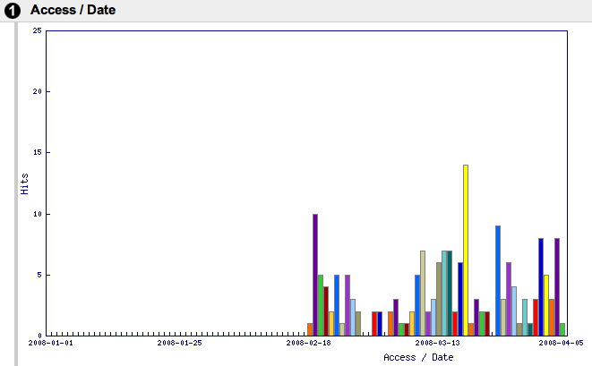  Step 8
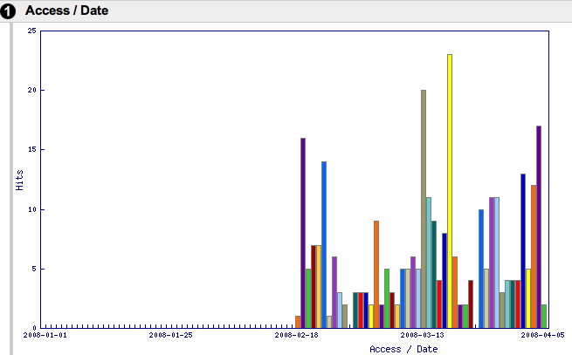  Step 1  Step 9 | 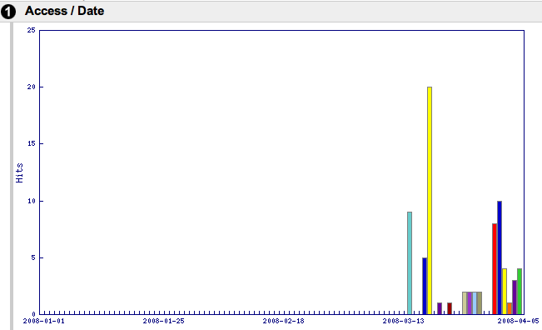  Step 10
Fig.21. SPSS vodcast downloads from 1 January through 5 April 2008

Students’ Evaluation of Podcasts

Student feedback on podcasts was gathered via the normal module feedback, and via a special online survey specifically about the details of how students used podcasts.

1) Module feedback at the end of each semester was done via online surveys for years 2, 3, and Masters (year 1 students were surveyed differently, with different questions, and thus will not be considered in this discussion). The following was the last question of each online survey: “If this module provided you with podcasts, please select the most appropriate: the podcasts were helpful, the podcasts made no real difference, the podcasts had a negative impact. Please write any additional comments regarding the podcasts.” We report on this feedback from semester 2 2006-07 and semester 1 2007-08.

Semester 2 2006-07:
1444 student from among years 2 through 4 filled out the module feedback surveys. Of these, 612 answered the following question as shown by the pie chart:
If this module provided you with podcasts, please select the most appropriate:

Fig.22. Semester 2 2006-07 Student opinion of podcasts (years 2 through 4)
159 students went on to comment. Comments were categorised as shown:
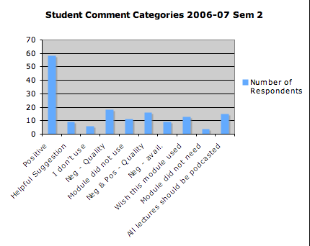

Fig.23. The 159 student podcast comments categorised.

Comment categories were further consolidated into three categories:

Final Category | Initial Category | Why?
I find podcasts useful | Positive  Negative due to Quality  Negative & Positive – Quality  Negative due to Availability  Wish this module used podcasts  All modules should podcast all lectures | All praise for podcasts  If quality were better I could make better use of podcasts  Same as above  If podcasts had been available, I would have used them  I wish podcasts had been used  Requesting blanket-coverage podcasting
I do not find podcasts useful | I don’t use  Module did not need pocasts | Students report that they just do not use podcasts  Even if they were available, podcasts were no real enhancement to this module
Objective Comment | Helpful Suggestion  Module did not use | Students were simply suggesting improvements to podcasting without offering own opinion  Fact: this module’s lecturer did not use podcasts

Comments were thus categorised and re-categorised in order to discern what the students think about the practical and pedagogical merits of podcasts, as well as to answer questions such as: in the Fig.22 pie chart, why do 4.08% of students feel that podcasts had a negative impact? Through filtering the survey data, it was discovered that all students who reported negative impact were in a single year 2 module. The instructor on that module experimented with making vodcasts, the end result of which were not quite up to students’ expectations of quality. Since the vodcasts were meant to be used in coursework, the students felt disadvantaged by less-than optimal podcast quality, and they made sure to express this in module evaluations. It is very useful to learn that, especially if podcasts are key to assessed work, students need good quality. It is also useful to see that students’ comments reveal that they truly find podcasts to be a useful tool to their learning.
Fig.24. Students’ podcasting comments consolidated into three main categories. Years 2 through 4, semester 2, 2006-07.
129

10

20

Semester 1 2007-08
The same module evaluations were answered by years 2 through 4, with the same podcast question:
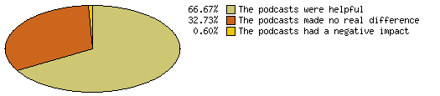

Fig.25. Students’ response to question of helpfulness of podcasts, module evaluations for years 2 through 4, semester 1 2007-08.

130 students went on to comment further regarding podcasts. Comments were categorised as in Figure 22, then consolidated in the same way as the chart above, finally yielding the breakdown into three main categories:
80

11

39

Fig.26. Students’ comments consolidated into the three main categories; semester 1, 2007-08.
There were fewer technical issues with podcasting in semester 2. The rise in the number of objective comments can be attributed to the number of students writing in comments “it would be good if this lecture could be recorded in both vodcast and podcast format, and both made available for download.” This semester also saw an increase in the number of students commenting that “this module had such engaging lectures, they did not need to be podcasted.” Four comments like this were made in 06-07; eight were made in 07-08. These comments increase the number of “I do not find podcasts useful” in the categorising scheme used, which is an overgeneralisation as it was in this particular module that podcasts were not deemed to be necessary. Even still, almost eight times as many students reported finding podcasts in that semester’s modules to be useful or desirable, as those who did not.

2) Special online survey about podcasts and vodcasts. All undergraduate and taught postgraduate students were invited, via email, to participate in an online survey with particular questions designed to reveal how students use podcasts and vodcasts. The email was sent in December 2007 and again in February 2008. Students were invited to fill out one survey on podcasts and a second survey on vodcasts, each survey consisting of the same 38 questions. Probably because this task turned to feel a bit onerous, only 41 students fully filled out the podcast survey and 34 filled out the vodcast survey. Still, some very interesting patterns emerged. The surveys with all responses are included as Appendices 3 and 4 of this report. Some observations:
10

20

- 100% of self-identified respondents with disabilities report that podcasts and vodcasts have both made positive impact on both their learning experience and on their marks.
- Of those who have not identified themselves as having a disability, 90% say learning experience has improved; 77% say marks have improved with podcasts. With vodcasts, 95% of this same group say learning experience has improved, and 90% say marks have improved.
- When asked how they listen to/view podcasts and vodcasts,
  - Up to 80% say they view online in the browser
  - Up to 30% say they view or listen on mp3 player
  - 90% say they download the files to their own computer. This supports the hypothesis that podcasts are more useful than other computerised helps because podcasts are portable and downloadable.
- 15% of podcast-users and 22% of vodcast-users claim they regularly use the files to catch up on missed lectures. While there is no question in the survey which may indicate whether or not missing lectures would be a deliberate choice given the existence of the files, the numbers suggest that there is at least the possibility students may make that choice.
- 92% of vodcast-users and 90% of podcast-users claim that they listen to/view the lecture multiple times.
- 58% of podcast-user and 67% of vodcast-users claim that they regularly listen to/view the lecture files with full attention. And 61% of podcast-users and 56% of vodcast-users claim to regularly write additional notes while doing this. It is very interesting to consider that in this case, writing notes has a completely different purpose than has writing notes in a live lecture. In a live lecture, one main purpose of writing is to record what the lecturer says. Whilst listening to a podcast, a student has no need to write for the purpose of recording. Writing then must act as a method of synthensizing and processing knowledge. This suggests that podcast and vodcasts support lectures by giving students a new vehicle by which they may process the knowledge gained from lectures.

The survey data paint a picture of students making full use of vodcast and podcast files to give themselves every additional chance to learn difficult and unfamiliar material. This is especially so for students with disabilities. While no survey question allowed to select for non-native speakers of English, there is a strong impression that these people would find podcasts to be as helpful as students with disabilities report them to be.

Student Marks

No attempt was made in this study to track the performance of individual students to try and ascertain whether podcast use might contribute to grades and academic performance. This would be an excellent topic for a future study. However, data was gathered regarding modules taught one year without podcasts. While admittedly not a true scientific comparison, the figures are nevertheless interesting.
In academic year 2005-06, a module in Emotion and Motivation was taught to 3rd years. In 2006-07, the same module was taught to 3rd years with the benefit of lectures having been vodcasted. In 2007-08, again the same module was taught with the benefit of vodcasts. The same instructor taught all three years. The average final marks for the class rose when lectures were vodcasted.

Fig.27. Class average marks over three academic years – the second two years with podcasts and vodcasts.

We also looked at a year 2 Neuropsychology module. In this case, another variable was introduced: a different teacher. Teacher 1 taught in 2004-05 without podcasts. Then teacher 2 took over in 2005-06, that year doing podcasts. A drop in final marks appeared that year. However, in the next year 2006-07, again with teacher 2 who again did podcasts with the addition of vodcasts, a significant rise in final marks can be seen.
Fig.28. Year 2 Neuropsychology average marks over 3 years.

Staff Feedback

Staff feedback was formally sought via an online survey, using SurveyMonkey. All staff who have taught in academic year 2006-07 or academic year 2007-08 were invited to participate. 22 responses were received. The survey consisted of 4 questions:

1. Please type your opinion(s) about podcasts in teaching.
2. If you have used podcasts in your teaching, was it: recording of live lectures, recording of material supplemental to lectures, other (please describe).
3. Did the use of podcasts save you time and/or hassle in any way?
4. If you answered yes to 3, please explain.

The responses to the first question are categorised here as fully positive, fully negative, or both negative and positive:

Figure 29. All teaching staff’s opinion of podcasts.

Of those thirteen who responded either fully or partially negative, their negative opinions were characterised as being either student-focused, teacher-focused, or both:
Fig. 30. Of the negative opinions, which focus on the student, which focus on the teacher, and which focus on both.

Representative Examples of Negative Opinions Focused on Students:
- “smacks of distance-learning”
- “I’m concerned about the impact it might have on lecture attendance”
- “They undermine good student practice, i.e., attending lectures and taking notes.”
- “I am dubious about how beneficial they are and student claims about listening while driving, gym, cleaning, sleeping, etc.”
- “Students think the only content they need for the exam is on the podcast.”
- “Putting things on a plate is a bad teaching paradigm.”

Representative Examples of Negative Opinions Focused on Teachers:
- “I have slight reservations about how my material may be used in the future if committed to podcast.”
- “the fact that we're expected to give up any control over their future use and assume any liability incurred as a result of that use leaves the lecturer in a untenably vulnerable position.”
- “I am not keen because I would find them inhibiting and worry about being quoted out of context. How easily are they used for inappropriate contexts”
- “There are legal issues of copyright and ownership that the university needs to address.”
- “Modules not using podcasts are downgraded in student opinion.”

Upon selecting only those respondents who had actually done podcasts, opinions were as follows:
Figure 31. The opinions of those who actually do podcasting.

As might be expected, those instructors who actually used podcasts were more positive. None expressed fully negative opinions. However, some expressed mixed opinions.

Representative Examples of Podcasters’ “Both Positive and Negative” Opinions of Podcasts
- “They are a valuable resource to support teaching. They are clearly of benefit to students of all abilities. They should be encouraged and supported by the school and university. There are legal issues of copyright and ownership that the university needs to address.”
- “I have very mixed views of podcasts. I think they are great for students who, for some reason, have difficulty following lectures (e.g. dyslexics who can't write quickly enough to take notes). However, I'm less happy that they are used generally for many lectures. First, I don't want students to think they can skip lectures. Second, I don't want something I present somewhat spontaneously, representing my view AT THAT TIME, to stand for time immemorial. The first of these points relates to the fact that I feel we sometimes err on the side of bending over backwards to make things convenient for students, at the possible expense of their educational needs. Putting things on a plate is a bad teaching paradigm. That said, I think podcasts have a place. My tutees seem to really appreciate Mike Beverley's stats tutorials/how to podcasts, for example, which seem to me to be an excellent use of the facility.”

Representative Examples of Podcasters’ Postive Opinions
- “Should be useful. Potentially allows students to miss lectures without detriment. Would allow 'a lecture' to be given whenever the student wished to take it so allowing lecturer/student contact time to be used differently.”
- “I think it is great. Both for students and for me (to review this year and in future years).”
- “Very useful. It helps the teacher significantly by providing valuable feedback on lecture delivery performance (e.g., pace of lecture, how to pause for questions and answers, explaining graphical and pictorial information).”
- “I think the students find them useful. I like the idea of having the podcasts as back-up. i.e. if I’m unavailable for some reason, a lecture would not necessarily have to be cancelled.”

Of the ten podcasters who chose to answer the question, “Did using podcasts/vodcasts save you time and/or hassle in any way,” five said yes and five said no. Six respondents went on to describe how podcasts saved them time and hassle:
1. It allowed me to avoid covering something in very great detail within class - and, thus, I presented it at a high-level in class, and referred students to the podcast mini-lesson for the detailed view. Also, when preparing to give my lectures this year, reviewing my podcast from last year proved very effective.
2. Not sure how they save time/hassle, except no explanations to students need to be given about why there are no podcasts.
3. Only in so far as answering student questions after lectures: rather than coming to see me, they tended to watch the vodcasts again.
4. Podcasts save hassle by directing students who have missed the lecture to follow the podcasts.
5. A number of students wanted my talk notes and I was able to direct them to the podcast as an alternative, saving me additional work and hassle.
6. I use vodcasts to teach psychology students how to use the statistical package SPSS. This has proved advantageous for a number of reasons: (1) less time required for teaching support required to run lab sessions; (2) fewer students attending support sessions; (3) they provide students with a resource that they can refer back to when they carry out their data analysis for their year three project.

No staff members were ever compelled or even very strongly encouraged to podcast their lectures. But survey feedback and personal conversations with lecturers revealed that some felt pressure by students to offer podcasts “because other lecturers are doing them,” even when they had reservations. The two most common negative opinions are 1) podcasts will cause students to skip lectures, and 2) I am not happy that the university holds full copyright to the content of my teaching which is now captured on a file. Both of these issues warrant closer inspection.

1. Does Podcasting Encourage Students to Skip Lectures?

Although in this study we had hoped to provide some qualitative data to answer this question, we were not able to implement a regular, airtight method of taking registers in lectures. However, we can report that for the past three consecutive semesters, over fifty percent of our lectures have been either podcasted or vodcasted. Podcasting lecturers were asked whether they saw attendance drop after the commencement of podcasting. Not one lecturer reported such an attendance drop. The Bangor Psychology programme has not turned into distance learning, as some instructors had feared. It is interesting to consider that two entire year groups have never attended university without podcasting, and also that more than one of our instructors have never lectured in our department without podcasting. Not only can these lecturers therefore not compare attendance to pre-podcasting days, but there are absolutely no complaints about low attendance. Rather, these lecturers have been inventing new ways of using podcasts and one is considering setting an assignment in which students must create their own podcasts. The evidence strongly suggests that attendance is simply not an issue.

2. Copyright Issues

Bangor University’s current Intellectual Property and Copyright policy has, under university legal advice, been applied to podcasts and communicated to staff in the following quotation from the official guidance document:

“Copyright
Any intellectual content included within the recording must either be that which has been generated by the lecturer, that which belongs to the university itself or, if third party content is included (e.g. images included within a Powerpoint presentation), must be dependent upon the explicit permission of the copyright-holder. It is up to the lecturer/organiser concerned to ensure that these conditions have been met and that copyright infringement has not taken place.

Performance
Visual or audio recordings of lectures (or debates, auditions, rehearsals etc) will inherently involve what the law would regard as a ‘performance’. The owner of this performance will be the person ‘performing’ (unlike intellectual content where the owner would be the ‘institution’). In order to be able to record this performance, a signature of permission is required along with agreement that the University can make this available when it wishes, even if that particular person has left the institution. However, Information Technology would respond positively, should that person, at a future date, make it clearly known that they no longer wish to have that recording of them made accessible.”

The difficulty with the copyright issue falls within the category of including third-party material and requiring that the lecturer take responsibility for settling rights to use them. For example, before podcasting, some staff perhaps did not even consider the legality of using in a presentation pictures or examples from a chosen textbook. But when arose the question of recording the lecture, especially recording projected images, staff realised that the legal issue needed to be understood and complied with. In one particular case, a lecturer, after having used photos from a textbook in lectures for many years, contacted the publisher to inquire whether the photos could be reproduced in a live lecture vodcast. The reply came that it was allowed if a one-thousand-dollar copyright payment were made, and that this payment was due for photo use in any lecture, whether or not recordings were made. This example illustrates the fact that in some ways, podcasting uncovers copyright issues which exist anyway.

In regards to the performance issue, some staff worry that if their lecture performance is in a sense signed over to the university in order to allow recordings to be made, they lose the right to make sure that performance is not used out of context or when they have left the university. They feel that it undermines job security and tends to undervalue their work and worth as an employee and scholar. Copyright issues in regards to podcasting have been discussed at a School level and to some extent at a university level. Some instructors who do podcasting have opted to protect their own work with a Creative Commons copyright. The Creative Commons website defines its copyright in this way: “Creative Commons defines the spectrum of possibilities between full copyright — all rights reserved — and the public domain — no rights reserved. Our licenses help you keep your copyright while inviting certain uses of your work — a “some rights reserved” copyright.” (CreativeCommons). In 2007, the Bangor student disabilities officer wrote to the Welsh Assembly to request that all Welsh universities allow academic staff to use Creative Commons copyrights for their own work. She did this in the hope that the university could then more strongly encourage academic staff to use podcasting. The discussion begun by this student is ongoing.

Is Creative Commons a “real” copyright? Garlick reported on the Creative Commons website (Garlick, 2006) that pioneering podcaster Adam Curry sued a Dutch tabloid for reproducing Curry’s photos which had been posted on Flickr and protected by a Creative Commons copyright. The tabloid had ignored the copyright and the court found against the tabloid. Thus, Creative Commons copyrights are enforceable.

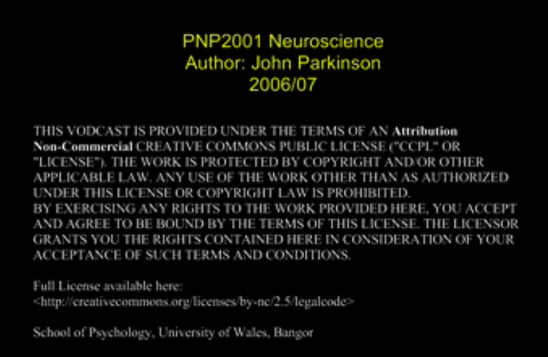
Figure 32. This lecturer begins every presentation with a slide explaining the terms of the Creative Commons public license he uses.

Though it is worthwhile to examine the negative concerns of staff, the fact is that every term between 60% and 75% of lecturers are podcasting. Many who used podcasts experimented with creative ways of giving supplemental information, using podcasts to keep a record of what was said in lectures and as an aid to prepare future lectures, and building assignments around vodcasts. Many found that podcasts helped them to deal with the large number of individual student queries that are inevitable in the internet age. Probably the most striking “podcasting plus” has been in the way statistics and research methods have been taught. Before podcasts, statistics skills were taught through large computer lab sessions in which up to 80 students watched the instructor demonstrate SPSS steps via a projector. Then the entire group attempted to imitate the steps. The instructor plus 3 or 4 teaching assistants would give personal assistance to make sure students could do the steps. Bangor Psychology class sizes are large, and thus this statistics lab needed to be offered 4 times or even 6 times weekly, just for the first years. This was difficult on the instructor and costly to the department. Now that vodcasts are being used, the only statistics lab sessions being scheduled are a one-hour daily drop-in session manned by one or two teaching assistants and sometimes joined by the main instructor when it gets busy close to assignment due dates. Students watch the vodcasts and go through the assignments, and come to the sessions only when they have particular problems. The school has saved much money in payment to teaching assistants, and the burden on the main instructor has been greatly lessened.

Conclusion

The main conclusions drawn can be categorised as technical, student-, and staff-related.

Podcasts are not an overwhelming technical challenge. The simple digital recording of a lecture or discussion is easy to make and to distribute via a VLE or website. Recording vodcasts is a bit more difficult, but is so highly valued by students that it is worth the effort. Distributing such files as true podcasts is certainly within the technical reach of any university web team, and is an affordable way of giving students extra study aids. We found that the more systematic the recording and distribution methods are, the best chance there is of faithful implementation by staff and utilisation by students.

A clear majority of students value podcasts and vodcasts. Students with special needs or with first languages other than English were especially grateful for this study aid and self-reported better understanding and even better grades as a result of their use. A minority of students indicated they did not feel the need to use them, but even these found pod- or vodcasts with additional (non-lecture) information helpful. A majority of students surveyed listen to podcasts after the lecture more than once, whilst concentrating and taking notes., implying that podcasts support rather than undermine lectures.

Skills teaching is one area which particularly benefits from vodcasts. Vodcasts offer individualised and replayable teaching, anytime and anywhere. Our own statistics teaching is now centred around the use of vodcasts, with complementary drop-in help sessions optional.

A significant percentage of staff remains wary about podcasts. Even some who are wary are willing to try it anyway, since they acknowledge that students seem to like podcasts. Those who positively try podcasting often come up with very innovative ways of using them, and benefit from the support podcasts give to the students.

In an era when the consumer aspect of university education is becoming more apparent, providing podcasts is an excellent way of adding value to the university course, and freely giving students something that truly supports learning. Podcasts support the individual needs of individual students, and are well-appreciated by students struggling with part-time job schedules or family responsibilities. Podcasts offer special help to those with special needs, from overseas, and in non-traditional age brackets. Bangor Psychology plans not only to continue using them, but to improve our methods by writing our own scripts to do recording and identifying episodes not just by date but by content to improve identification and usability.

Appendix 1
Python script which generates XML file holding podcast information
This file is read and rendered by most browsers and aggregator software titles such as iTunes.
#! /usr/bin/python
import os
import time
from shutil import copy

srcFilePath='/Users/sysadmin/Desktop/Received/'
fileList=os.listdir(srcFilePath)

fileList1=os.listdir('/Library/WebServer/html/200607/sem2/1/')
fileList2=os.listdir('/Library/WebServer/html/200607/sem2/2/')
fileList3=os.listdir('/Library/WebServer/html/200607/sem2/3/')
fileList4=os.listdir('/Library/WebServer/html/200607/sem2/4/')
fileListx=os.listdir('/Library/WebServer/html/200607/sem2/x/')

for file in fileList:
st = os.stat('/Users/sysadmin/Desktop/Received/'+file)
mode, ino, dev, nlink, uid, gid, size, atime, mtime, ctime = st
year = file[3:4]
disability = file[7:8]
if file not in fileList1 and file not in fileList2 and file not in fileList3 and file not in fileList4 and disability != 'x' and file != '.DS_Store':
dstFilePath = '/Library/WebServer/html/200607/sem2/' + year + '/'
copy(srcFilePath+file, dstFilePath)
if file not in fileList1 and file not in fileList2 and file not in fileList3 and file not in fileList4 and disability == 'x' and file != '.DS_Store':
dstFilePath = '/Library/WebServer/html/200607/sem2/x/'
copy(srcFilePath+file, dstFilePath)

for i in ['1','2','3','4','x']:
fileList=os.listdir('/Library/WebServer/html/200607/sem2/'+i+'/')
os.remove('/Library/WebServer/html/200607/sem2/'+i+'/podcast.xml')
f=os.open('/Library/WebServer/html/200607/sem2/'+i+'/podcast.xml', os.O_RDWR | os.O_CREAT)
link='http://psycast.bangor.ac.uk/200607/sem2/'+i+'/'
if i == 'x':
os.write(f,"""<?xml version="1.0" encoding="UTF-8"?>

<rss xmlns:itunes="http://www.itunes.com/dtds/podcast-1.0.dtd" version="2.0">

<channel>

<title>Disability Lecture Podcasts</title>

<link>http://psycast.bangor.ac.uk/200607/sem2/x/</link>

<language>en-us</language>

<copyright>&#x2117; &amp; &#xA9; 2005 School of Psychology, UWB</copyright>

<itunes:subtitle>Disability Lectures</itunes:subtitle>

<itunes:author>School of Psychology</itunes:author>

<itunes:summary>Audio recordings for disabled students</itunes:summary>

<description>Audio recordings made available for the disabled students only. Look for our Podcast in the iTunes Music Store</description>

<itunes:owner>

<itunes:name>Sionwyn Morris</itunes:name>

<itunes:email>s.w.morris@bangor.ac.uk</itunes:email>

</itunes:owner>

<itunes:image href="http://psycast.bangor.ac.uk/200607/psych.jpg" />

<itunes:category text="Education">

<itunes:category text="Higher Education"/>

</itunes:category>

""")
else:
os.write(f,"""<?xml version="1.0" encoding="UTF-8"?>

<rss xmlns:itunes="http://www.itunes.com/dtds/podcast-1.0.dtd" version="2.0">

<channel>

<title>Year %s Lecture Podcasts</title>

<link>http://psycast.bangor.ac.uk/200607/sem2/%s/</link>

<language>en-us</language>

<copyright>&#x2117; &amp; &#xA9; 2005 School of Psychology, UWB</copyright>

<itunes:subtitle>Year %s Lectures</itunes:subtitle>

<itunes:author>School of Psychology</itunes:author>

<itunes:summary>Audio recordings for the year %s psychology lectures</itunes:summary>

<description>Audio recordings for the year %s psychology lectures. Look for our Podcast in the iTunes Music Store</description>

<itunes:owner>

<itunes:name>Sionwyn Morris</itunes:name>

<itunes:email>s.w.morris@bangor.ac.uk</itunes:email>

</itunes:owner>

<itunes:image href="http://psycast.bangor.ac.uk/200607/psych.jpg" />

<itunes:category text="Education">

<itunes:category text="Higher Education"/>

</itunes:category>

""" %(i, i, i, i, i))

for file in fileList:
st = os.stat('/Library/WebServer/html/200607/sem2/'+i+'/' + file)
mode, ino, dev, nlink, uid, gid, size, atime, mtime, ctime = st
date=time.strftime('%a, %d %b %Y %H:%M:%S +0000', time.gmtime(mtime))
title_date=time.strftime('%a (%d-%m-%Y)', time.gmtime(mtime))
summary_date=time.strftime('%d-%m-%Y', time.gmtime(mtime))
module_code = file[:7]
file_type=file[-4:]
url='http://psycast.bangor.ac.uk/200607/sem2/'+i+'/'

if file_type == '.mp3':
file_type = 'audio/mpeg'
elif file_type == '.m4a':
file_type = 'audio/x-m4a'
elif file_type == '.mp4':
file_type = 'video/mp4'
elif file_type == '.m4v':
file_type = 'video/x-m4v'
elif file_type == '.mov':
fily_type = 'video/quicktime'

if file !='.DS_Store' and file != 'podcast.xml':
os.write(f,"""
<item>

<title>%s %s</title>

<itunes:author>School of Psychology</itunes:author>

<itunes:subtitle>%s Lecture</itunes:subtitle>

<itunes:summary>The %s lecture on %s</itunes:summary>

<enclosure url="%s%s" length="%s" type="%s" />

<guid>%s%s</guid>

<pubDate>%s</pubDate>

<itunes:duration>1:48:42</itunes:duration>

<itunes:keywords>%s, Psychology, Bangor, UWB</itunes:keywords>

</item>

""" %(module_code , title_date, module_code, module_code, summary_date, url, file, size, file_type, url, file, date, module_code))

os.write(f,"""</channel>

</rss>""")

os.close(f)

Appendix 2
XML File displaying a podcast
(Figure 4 of the report shows how a browser displays this file)
<?xml version="1.0" encoding="UTF-8"?>

<rss xmlns:itunes="http://www.itunes.com/dtds/podcast-1.0.dtd" version="2.0">

<channel>

<title>Year 3 Lecture Podcasts</title>

<link>http://psycast.bangor.ac.uk/200708/sem2/3/</link>

<language>en-us</language>

<copyright>&#x2117; &amp; &#xA9; 2005 School of Psychology, UWB</copyright>

<itunes:subtitle>Year 3 Lectures</itunes:subtitle>

<itunes:author>School of Psychology</itunes:author>

<itunes:summary>Audio recordings for the year 3 psychology lectures</itunes:summary>

<description>Audio recordings for the year 3 psychology lectures. Look for our Podcast in the iTunes Music Store</description>

<itunes:owner>

<itunes:name>Sionwyn Morris</itunes:name>

<itunes:email>s.w.morris@bangor.ac.uk</itunes:email>

</itunes:owner>

<itunes:image href="../../../images/psych.jpg" />

<itunes:category text="Education">

<itunes:category text="Higher Education"/>

</itunes:category>

<item>

<title>PCP3004 14-02-2008</title>

<itunes:author>School of Psychology</itunes:author>

<itunes:subtitle>PCP3004 Lecture</itunes:subtitle>

<itunes:summary>The PCP3004 lecture on 14-02-2008</itunes:summary>

<enclosure url="http://psycast.bangor.ac.uk/200708/sem2/03/PCP3004mon_2008-02-11.mp3" length="91262618" type=".mp3" />

<guid>http://psycast.bangor.ac.uk/200708/sem2/03/PCP3004mon_2008-02-11.mp3</guid>

<pubDate>Thu, 14 Feb 2008 14:00:16 +0000</pubDate>

<itunes:duration>1:48:42</itunes:duration>

<itunes:keywords>PCP3004, Psychology, Bangor, UWB</itunes:keywords>

</item>
<item>

<title>PCP3004 20-02-2008</title>

<itunes:author>School of Psychology</itunes:author>

<itunes:subtitle>PCP3004 Lecture</itunes:subtitle>

<itunes:summary>The PCP3004 lecture on 20-02-2008</itunes:summary>

<enclosure url="http://psycast.bangor.ac.uk/200708/sem2/03/PCP3004mon_2008-02-18.mp3" length="57101190" type=".mp3" />

<guid>http://psycast.bangor.ac.uk/200708/sem2/03/PCP3004mon_2008-02-18.mp3</guid>

<pubDate>Wed, 20 Feb 2008 15:06:16 +0000</pubDate>

<itunes:duration>1:48:42</itunes:duration>

<itunes:keywords>PCP3004, Psychology, Bangor, UWB</itunes:keywords>

</item>
<item>

<title>PCP3004 04-03-2008</title>

<itunes:author>School of Psychology</itunes:author>

<itunes:subtitle>PCP3004 Lecture</itunes:subtitle>

<itunes:summary>The PCP3004 lecture on 04-03-2008</itunes:summary>

<enclosure url="http://psycast.bangor.ac.uk/200708/sem2/03/PCP3004mon_2008-25-02.mp3" length="100836831" type=".mp3" />

<guid>http://psycast.bangor.ac.uk/200708/sem2/03/PCP3004mon_2008-25-02.mp3</guid>

<pubDate>Tue, 04 Mar 2008 15:20:07 +0000</pubDate>

<itunes:duration>1:48:42</itunes:duration>

<itunes:keywords>PCP3004, Psychology, Bangor, UWB</itunes:keywords>

</item>
<item>

<title>PCP3004 05-02-2008</title>

<itunes:author>School of Psychology</itunes:author>

<itunes:subtitle>PCP3004 Lecture</itunes:subtitle>

<itunes:summary>The PCP3004 lecture on 05-02-2008</itunes:summary>

<enclosure url="http://psycast.bangor.ac.uk/200708/sem2/03/PCP3004tue_2008-02-05.mp3" length="105610304" type=".mp3" />

<guid>http://psycast.bangor.ac.uk/200708/sem2/03/PCP3004tue_2008-02-05.mp3</guid>

<pubDate>Tue, 05 Feb 2008 14:00:00 +0000</pubDate>

<itunes:duration>1:48:42</itunes:duration>

<itunes:keywords>PCP3004, Psychology, Bangor, UWB</itunes:keywords>

</item>
<item>

<title>PCP3004 12-02-2008</title>

<itunes:author>School of Psychology</itunes:author>

<itunes:subtitle>PCP3004 Lecture</itunes:subtitle>

<itunes:summary>The PCP3004 lecture on 12-02-2008</itunes:summary>

<enclosure url="http://psycast.bangor.ac.uk/200708/sem2/03/PCP3004tue_2008-02-12.mp3" length="105617216" type=".mp3" />

<guid>http://psycast.bangor.ac.uk/200708/sem2/03/PCP3004tue_2008-02-12.mp3</guid>

<pubDate>Tue, 12 Feb 2008 14:00:00 +0000</pubDate>

<itunes:duration>1:48:42</itunes:duration>

<itunes:keywords>PCP3004, Psychology, Bangor, UWB</itunes:keywords>

</item>
<item>

<title>PCP3004 19-02-2008</title>

<itunes:author>School of Psychology</itunes:author>

<itunes:subtitle>PCP3004 Lecture</itunes:subtitle>

<itunes:summary>The PCP3004 lecture on 19-02-2008</itunes:summary>

<enclosure url="http://psycast.bangor.ac.uk/200708/sem2/03/PCP3004tue_2008-02-19.mp3" length="105617216" type=".mp3" />

<guid>http://psycast.bangor.ac.uk/200708/sem2/03/PCP3004tue_2008-02-19.mp3</guid>

<pubDate>Tue, 19 Feb 2008 14:00:00 +0000</pubDate>

<itunes:duration>1:48:42</itunes:duration>

<itunes:keywords>PCP3004, Psychology, Bangor, UWB</itunes:keywords>

</item>
<item>

<title>PCP3005 28-01-2008</title>

<itunes:author>School of Psychology</itunes:author>

<itunes:subtitle>PCP3005 Lecture</itunes:subtitle>

<itunes:summary>The PCP3005 lecture on 28-01-2008</itunes:summary>

<enclosure url="http://psycast.bangor.ac.uk/200708/sem2/03/PCP3005mon_2008-01-28.mp3" length="105610880" type=".mp3" />

<guid>http://psycast.bangor.ac.uk/200708/sem2/03/PCP3005mon_2008-01-28.mp3</guid>

<pubDate>Mon, 28 Jan 2008 18:00:00 +0000</pubDate>

<itunes:duration>1:48:42</itunes:duration>

<itunes:keywords>PCP3005, Psychology, Bangor, UWB</itunes:keywords>

</item>
<item>

<title>PCP3005 31-01-2008</title>

<itunes:author>School of Psychology</itunes:author>

<itunes:subtitle>PCP3005 Lecture</itunes:subtitle>

<itunes:summary>The PCP3005 lecture on 31-01-2008</itunes:summary>

<enclosure url="http://psycast.bangor.ac.uk/200708/sem2/03/PCP3005thu_2008-01-31.mp3" length="105616064" type=".mp3" />

<guid>http://psycast.bangor.ac.uk/200708/sem2/03/PCP3005thu_2008-01-31.mp3</guid>

<pubDate>Thu, 31 Jan 2008 14:00:00 +0000</pubDate>

<itunes:duration>1:48:42</itunes:duration>

<itunes:keywords>PCP3005, Psychology, Bangor, UWB</itunes:keywords>

</item>
<item>

<title>PCP3005 07-02-2008</title>

<itunes:author>School of Psychology</itunes:author>

<itunes:subtitle>PCP3005 Lecture</itunes:subtitle>

<itunes:summary>The PCP3005 lecture on 07-02-2008</itunes:summary>

<enclosure url="http://psycast.bangor.ac.uk/200708/sem2/03/PCP3005thu_2008-02-07.mov" length="124779259" type=".mov" />

<guid>http://psycast.bangor.ac.uk/200708/sem2/03/PCP3005thu_2008-02-07.mov</guid>

<pubDate>Thu, 07 Feb 2008 17:37:23 +0000</pubDate>

<itunes:duration>1:48:42</itunes:duration>

<itunes:keywords>PCP3005, Psychology, Bangor, UWB</itunes:keywords>

</item>
<item>

<title>PCP3005 14-02-2008</title>

<itunes:author>School of Psychology</itunes:author>

<itunes:subtitle>PCP3005 Lecture</itunes:subtitle>

<itunes:summary>The PCP3005 lecture on 14-02-2008</itunes:summary>

<enclosure url="http://psycast.bangor.ac.uk/200708/sem2/03/PCP3005thu_2008-02-14.mp3" length="105430016" type=".mp3" />

<guid>http://psycast.bangor.ac.uk/200708/sem2/03/PCP3005thu_2008-02-14.mp3</guid>

<pubDate>Thu, 14 Feb 2008 14:00:00 +0000</pubDate>

<itunes:duration>1:48:42</itunes:duration>

<itunes:keywords>PCP3005, Psychology, Bangor, UWB</itunes:keywords>

</item>
<item>

<title>PCP3005 06-03-2008</title>

<itunes:author>School of Psychology</itunes:author>

<itunes:subtitle>PCP3005 Lecture</itunes:subtitle>

<itunes:summary>The PCP3005 lecture on 06-03-2008</itunes:summary>

<enclosure url="http://psycast.bangor.ac.uk/200708/sem2/03/PCP3005thu_2008-03-06.mp3" length="105616064" type=".mp3" />

<guid>http://psycast.bangor.ac.uk/200708/sem2/03/PCP3005thu_2008-03-06.mp3</guid>

<pubDate>Thu, 06 Mar 2008 14:00:00 +0000</pubDate>

<itunes:duration>1:48:42</itunes:duration>

<itunes:keywords>PCP3005, Psychology, Bangor, UWB</itunes:keywords>

</item>
<item>

<title>PCP3006 06-02-2008</title>

<itunes:author>School of Psychology</itunes:author>

<itunes:subtitle>PCP3006 Lecture</itunes:subtitle>

<itunes:summary>The PCP3006 lecture on 06-02-2008</itunes:summary>

<enclosure url="http://psycast.bangor.ac.uk/200708/sem2/03/PCP3006wed_2008-01-30.mp3" length="45307545" type=".mp3" />

<guid>http://psycast.bangor.ac.uk/200708/sem2/03/PCP3006wed_2008-01-30.mp3</guid>

<pubDate>Wed, 06 Feb 2008 17:13:14 +0000</pubDate>

<itunes:duration>1:48:42</itunes:duration>

<itunes:keywords>PCP3006, Psychology, Bangor, UWB</itunes:keywords>

</item>
<item>

<title>PCP3006 06-02-2008</title>

<itunes:author>School of Psychology</itunes:author>

<itunes:subtitle>PCP3006 Lecture</itunes:subtitle>

<itunes:summary>The PCP3006 lecture on 06-02-2008</itunes:summary>

<enclosure url="http://psycast.bangor.ac.uk/200708/sem2/03/PCP3006wed_2008-02-06.mp3" length="44515017" type=".mp3" />

<guid>http://psycast.bangor.ac.uk/200708/sem2/03/PCP3006wed_2008-02-06.mp3</guid>

<pubDate>Wed, 06 Feb 2008 17:13:03 +0000</pubDate>

<itunes:duration>1:48:42</itunes:duration>

<itunes:keywords>PCP3006, Psychology, Bangor, UWB</itunes:keywords>

</item>
<item>

<title>PCP3006 25-02-2008</title>

<itunes:author>School of Psychology</itunes:author>

<itunes:subtitle>PCP3006 Lecture</itunes:subtitle>

<itunes:summary>The PCP3006 lecture on 25-02-2008</itunes:summary>

<enclosure url="http://psycast.bangor.ac.uk/200708/sem2/03/PCP3006wed_2008-02-13.mp3" length="44438001" type=".mp3" />

<guid>http://psycast.bangor.ac.uk/200708/sem2/03/PCP3006wed_2008-02-13.mp3</guid>

<pubDate>Mon, 25 Feb 2008 15:36:19 +0000</pubDate>

<itunes:duration>1:48:42</itunes:duration>

<itunes:keywords>PCP3006, Psychology, Bangor, UWB</itunes:keywords>

</item>
<item>

<title>PCP3006 25-02-2008</title>

<itunes:author>School of Psychology</itunes:author>

<itunes:subtitle>PCP3006 Lecture</itunes:subtitle>

<itunes:summary>The PCP3006 lecture on 25-02-2008</itunes:summary>

<enclosure url="http://psycast.bangor.ac.uk/200708/sem2/03/PCP3006wed_2008-02-20.mp3" length="46079217" type=".mp3" />

<guid>http://psycast.bangor.ac.uk/200708/sem2/03/PCP3006wed_2008-02-20.mp3</guid>

<pubDate>Mon, 25 Feb 2008 15:36:52 +0000</pubDate>

<itunes:duration>1:48:42</itunes:duration>

<itunes:keywords>PCP3006, Psychology, Bangor, UWB</itunes:keywords>

</item>
<item>

<title>PCP3006 04-03-2008</title>

<itunes:author>School of Psychology</itunes:author>

<itunes:subtitle>PCP3006 Lecture</itunes:subtitle>

<itunes:summary>The PCP3006 lecture on 04-03-2008</itunes:summary>

<enclosure url="http://psycast.bangor.ac.uk/200708/sem2/03/PCP3006wed_2008-02-27.mp3" length="45766425" type=".mp3" />

<guid>http://psycast.bangor.ac.uk/200708/sem2/03/PCP3006wed_2008-02-27.mp3</guid>

<pubDate>Tue, 04 Mar 2008 11:49:59 +0000</pubDate>

<itunes:duration>1:48:42</itunes:duration>

<itunes:keywords>PCP3006, Psychology, Bangor, UWB</itunes:keywords>

</item>
<item>

<title>PCP3006 12-03-2008</title>

<itunes:author>School of Psychology</itunes:author>

<itunes:subtitle>PCP3006 Lecture</itunes:subtitle>

<itunes:summary>The PCP3006 lecture on 12-03-2008</itunes:summary>

<enclosure url="http://psycast.bangor.ac.uk/200708/sem2/03/PCP3006wed_2008-03-05.mp3" length="45013617" type=".mp3" />

<guid>http://psycast.bangor.ac.uk/200708/sem2/03/PCP3006wed_2008-03-05.mp3</guid>

<pubDate>Wed, 12 Mar 2008 11:21:17 +0000</pubDate>

<itunes:duration>1:48:42</itunes:duration>

<itunes:keywords>PCP3006, Psychology, Bangor, UWB</itunes:keywords>

</item>
<item>

<title>PDP3001 31-01-2008</title>

<itunes:author>School of Psychology</itunes:author>

<itunes:subtitle>PDP3001 Lecture</itunes:subtitle>

<itunes:summary>The PDP3001 lecture on 31-01-2008</itunes:summary>

<enclosure url="http://psycast.bangor.ac.uk/200708/sem2/03/PDP3001thu_2008-01-31.mp3" length="105617216" type=".mp3" />

<guid>http://psycast.bangor.ac.uk/200708/sem2/03/PDP3001thu_2008-01-31.mp3</guid>

<pubDate>Thu, 31 Jan 2008 11:00:00 +0000</pubDate>

<itunes:duration>1:48:42</itunes:duration>

<itunes:keywords>PDP3001, Psychology, Bangor, UWB</itunes:keywords>

</item>
<item>

<title>PDP3001 07-02-2008</title>

<itunes:author>School of Psychology</itunes:author>

<itunes:subtitle>PDP3001 Lecture</itunes:subtitle>

<itunes:summary>The PDP3001 lecture on 07-02-2008</itunes:summary>

<enclosure url="http://psycast.bangor.ac.uk/200708/sem2/03/PDP3001thu_2008-02-07.mp3" length="105616640" type=".mp3" />

<guid>http://psycast.bangor.ac.uk/200708/sem2/03/PDP3001thu_2008-02-07.mp3</guid>

<pubDate>Thu, 07 Feb 2008 11:00:00 +0000</pubDate>

<itunes:duration>1:48:42</itunes:duration>

<itunes:keywords>PDP3001, Psychology, Bangor, UWB</itunes:keywords>

</item>
<item>

<title>PDP3001 14-02-2008</title>

<itunes:author>School of Psychology</itunes:author>

<itunes:subtitle>PDP3001 Lecture</itunes:subtitle>

<itunes:summary>The PDP3001 lecture on 14-02-2008</itunes:summary>

<enclosure url="http://psycast.bangor.ac.uk/200708/sem2/03/PDP3001thu_2008-02-14.mp3" length="105617216" type=".mp3" />

<guid>http://psycast.bangor.ac.uk/200708/sem2/03/PDP3001thu_2008-02-14.mp3</guid>

<pubDate>Thu, 14 Feb 2008 11:00:00 +0000</pubDate>

<itunes:duration>1:48:42</itunes:duration>

<itunes:keywords>PDP3001, Psychology, Bangor, UWB</itunes:keywords>

</item>
<item>

<title>PDP3001 21-02-2008</title>

<itunes:author>School of Psychology</itunes:author>

<itunes:subtitle>PDP3001 Lecture</itunes:subtitle>

<itunes:summary>The PDP3001 lecture on 21-02-2008</itunes:summary>

<enclosure url="http://psycast.bangor.ac.uk/200708/sem2/03/PDP3001thu_2008-02-21.mp3" length="105616064" type=".mp3" />

<guid>http://psycast.bangor.ac.uk/200708/sem2/03/PDP3001thu_2008-02-21.mp3</guid>

<pubDate>Thu, 21 Feb 2008 11:00:00 +0000</pubDate>

<itunes:duration>1:48:42</itunes:duration>

<itunes:keywords>PDP3001, Psychology, Bangor, UWB</itunes:keywords>

</item>
<item>

<title>PDP3003 06-02-2008</title>

<itunes:author>School of Psychology</itunes:author>

<itunes:subtitle>PDP3003 Lecture</itunes:subtitle>

<itunes:summary>The PDP3003 lecture on 06-02-2008</itunes:summary>

<enclosure url="http://psycast.bangor.ac.uk/200708/sem2/03/PDP3003mon_2008-02-04.mp3" length="93540962" type=".mp3" />

<guid>http://psycast.bangor.ac.uk/200708/sem2/03/PDP3003mon_2008-02-04.mp3</guid>

<pubDate>Wed, 06 Feb 2008 16:48:37 +0000</pubDate>

<itunes:duration>1:48:42</itunes:duration>

<itunes:keywords>PDP3003, Psychology, Bangor, UWB</itunes:keywords>

</item>
<item>

<title>PDP3003 14-02-2008</title>

<itunes:author>School of Psychology</itunes:author>

<itunes:subtitle>PDP3003 Lecture</itunes:subtitle>

<itunes:summary>The PDP3003 lecture on 14-02-2008</itunes:summary>

<enclosure url="http://psycast.bangor.ac.uk/200708/sem2/03/PDP3003mon_2008-02-11.mp3" length="84593690" type=".mp3" />

<guid>http://psycast.bangor.ac.uk/200708/sem2/03/PDP3003mon_2008-02-11.mp3</guid>

<pubDate>Thu, 14 Feb 2008 14:59:40 +0000</pubDate>

<itunes:duration>1:48:42</itunes:duration>

<itunes:keywords>PDP3003, Psychology, Bangor, UWB</itunes:keywords>

</item>
<item>

<title>PDP3003 04-03-2008</title>

<itunes:author>School of Psychology</itunes:author>

<itunes:subtitle>PDP3003 Lecture</itunes:subtitle>

<itunes:summary>The PDP3003 lecture on 04-03-2008</itunes:summary>

<enclosure url="http://psycast.bangor.ac.uk/200708/sem2/03/PDP3003mon_2008-25-02-a.mp3" length="47317994" type=".mp3" />

<guid>http://psycast.bangor.ac.uk/200708/sem2/03/PDP3003mon_2008-25-02-a.mp3</guid>

<pubDate>Tue, 04 Mar 2008 15:26:37 +0000</pubDate>

<itunes:duration>1:48:42</itunes:duration>

<itunes:keywords>PDP3003, Psychology, Bangor, UWB</itunes:keywords>

</item>
<item>

<title>PDP3003 04-03-2008</title>

<itunes:author>School of Psychology</itunes:author>

<itunes:subtitle>PDP3003 Lecture</itunes:subtitle>

<itunes:summary>The PDP3003 lecture on 04-03-2008</itunes:summary>

<enclosure url="http://psycast.bangor.ac.uk/200708/sem2/03/PDP3003mon_2008-25-02-b.mp3" length="31796662" type=".mp3" />

<guid>http://psycast.bangor.ac.uk/200708/sem2/03/PDP3003mon_2008-25-02-b.mp3</guid>

<pubDate>Tue, 04 Mar 2008 15:15:41 +0000</pubDate>

<itunes:duration>1:48:42</itunes:duration>

<itunes:keywords>PDP3003, Psychology, Bangor, UWB</itunes:keywords>

</item>
<item>

<title>PLP3002 01-02-2008</title>

<itunes:author>School of Psychology</itunes:author>

<itunes:subtitle>PLP3002 Lecture</itunes:subtitle>

<itunes:summary>The PLP3002 lecture on 01-02-2008</itunes:summary>

<enclosure url="http://psycast.bangor.ac.uk/200708/sem2/03/PLP3002fri_2008-02-01.mp3" length="87456730" type=".mp3" />

<guid>http://psycast.bangor.ac.uk/200708/sem2/03/PLP3002fri_2008-02-01.mp3</guid>

<pubDate>Fri, 01 Feb 2008 13:44:14 +0000</pubDate>

<itunes:duration>1:48:42</itunes:duration>

<itunes:keywords>PLP3002, Psychology, Bangor, UWB</itunes:keywords>

</item>
<item>

<title>PLP3002 08-02-2008</title>

<itunes:author>School of Psychology</itunes:author>

<itunes:subtitle>PLP3002 Lecture</itunes:subtitle>

<itunes:summary>The PLP3002 lecture on 08-02-2008</itunes:summary>

<enclosure url="http://psycast.bangor.ac.uk/200708/sem2/03/PLP3002fri_2008-02-08.mp3" length="105643806" type=".mp3" />

<guid>http://psycast.bangor.ac.uk/200708/sem2/03/PLP3002fri_2008-02-08.mp3</guid>

<pubDate>Fri, 08 Feb 2008 13:35:50 +0000</pubDate>

<itunes:duration>1:48:42</itunes:duration>

<itunes:keywords>PLP3002, Psychology, Bangor, UWB</itunes:keywords>

</item>
<item>

<title>PLP3002 15-02-2008</title>

<itunes:author>School of Psychology</itunes:author>

<itunes:subtitle>PLP3002 Lecture</itunes:subtitle>

<itunes:summary>The PLP3002 lecture on 15-02-2008</itunes:summary>

<enclosure url="http://psycast.bangor.ac.uk/200708/sem2/03/PLP3002fri_2008-02-15.mp3" length="95843081" type=".mp3" />

<guid>http://psycast.bangor.ac.uk/200708/sem2/03/PLP3002fri_2008-02-15.mp3</guid>

<pubDate>Fri, 15 Feb 2008 13:35:26 +0000</pubDate>

<itunes:duration>1:48:42</itunes:duration>

<itunes:keywords>PLP3002, Psychology, Bangor, UWB</itunes:keywords>

</item>
<item>

<title>PLP3002 05-03-2008</title>

<itunes:author>School of Psychology</itunes:author>

<itunes:subtitle>PLP3002 Lecture</itunes:subtitle>

<itunes:summary>The PLP3002 lecture on 05-03-2008</itunes:summary>

<enclosure url="http://psycast.bangor.ac.uk/200708/sem2/03/PLP3002fri_2008-02-29.mp3" length="92153337" type=".mp3" />

<guid>http://psycast.bangor.ac.uk/200708/sem2/03/PLP3002fri_2008-02-29.mp3</guid>

<pubDate>Wed, 05 Mar 2008 17:30:05 +0000</pubDate>

<itunes:duration>1:48:42</itunes:duration>

<itunes:keywords>PLP3002, Psychology, Bangor, UWB</itunes:keywords>

</item>
<item>

<title>PLP3002 07-03-2008</title>

<itunes:author>School of Psychology</itunes:author>

<itunes:subtitle>PLP3002 Lecture</itunes:subtitle>

<itunes:summary>The PLP3002 lecture on 07-03-2008</itunes:summary>

<enclosure url="http://psycast.bangor.ac.uk/200708/sem2/03/PLP3002fri_2008-03-07.mp3" length="90950033" type=".mp3" />

<guid>http://psycast.bangor.ac.uk/200708/sem2/03/PLP3002fri_2008-03-07.mp3</guid>

<pubDate>Fri, 07 Mar 2008 15:42:55 +0000</pubDate>

<itunes:duration>1:48:42</itunes:duration>

<itunes:keywords>PLP3002, Psychology, Bangor, UWB</itunes:keywords>

</item>
<item>

<title>PSP3003 31-01-2008</title>

<itunes:author>School of Psychology</itunes:author>

<itunes:subtitle>PSP3003 Lecture</itunes:subtitle>

<itunes:summary>The PSP3003 lecture on 31-01-2008</itunes:summary>

<enclosure url="http://psycast.bangor.ac.uk/200708/sem2/03/PSP3003thu_2008-01-31.mp3" length="105616064" type=".mp3" />

<guid>http://psycast.bangor.ac.uk/200708/sem2/03/PSP3003thu_2008-01-31.mp3</guid>

<pubDate>Thu, 31 Jan 2008 18:00:00 +0000</pubDate>

<itunes:duration>1:48:42</itunes:duration>

<itunes:keywords>PSP3003, Psychology, Bangor, UWB</itunes:keywords>

</item>
<item>

<title>PSP3003 07-02-2008</title>

<itunes:author>School of Psychology</itunes:author>

<itunes:subtitle>PSP3003 Lecture</itunes:subtitle>

<itunes:summary>The PSP3003 lecture on 07-02-2008</itunes:summary>

<enclosure url="http://psycast.bangor.ac.uk/200708/sem2/03/PSP3003thu_2008-02-07.mp3" length="105616640" type=".mp3" />

<guid>http://psycast.bangor.ac.uk/200708/sem2/03/PSP3003thu_2008-02-07.mp3</guid>

<pubDate>Thu, 07 Feb 2008 18:00:00 +0000</pubDate>

<itunes:duration>1:48:42</itunes:duration>

<itunes:keywords>PSP3003, Psychology, Bangor, UWB</itunes:keywords>

</item>
<item>

<title>PSP3003 14-02-2008</title>

<itunes:author>School of Psychology</itunes:author>

<itunes:subtitle>PSP3003 Lecture</itunes:subtitle>

<itunes:summary>The PSP3003 lecture on 14-02-2008</itunes:summary>

<enclosure url="http://psycast.bangor.ac.uk/200708/sem2/03/PSP3003thu_2008-02-14.mp3" length="105614336" type=".mp3" />

<guid>http://psycast.bangor.ac.uk/200708/sem2/03/PSP3003thu_2008-02-14.mp3</guid>

<pubDate>Thu, 14 Feb 2008 18:00:00 +0000</pubDate>

<itunes:duration>1:48:42</itunes:duration>

<itunes:keywords>PSP3003, Psychology, Bangor, UWB</itunes:keywords>

</item>
<item>

<title>PSP3003 21-02-2008</title>

<itunes:author>School of Psychology</itunes:author>

<itunes:subtitle>PSP3003 Lecture</itunes:subtitle>

<itunes:summary>The PSP3003 lecture on 21-02-2008</itunes:summary>

<enclosure url="http://psycast.bangor.ac.uk/200708/sem2/03/PSP3003thu_2008-02-21.mp3" length="105616640" type=".mp3" />

<guid>http://psycast.bangor.ac.uk/200708/sem2/03/PSP3003thu_2008-02-21.mp3</guid>

<pubDate>Thu, 21 Feb 2008 18:00:00 +0000</pubDate>

<itunes:duration>1:48:42</itunes:duration>

<itunes:keywords>PSP3003, Psychology, Bangor, UWB</itunes:keywords>

</item>
<item>

<title>PSP3003 28-02-2008</title>

<itunes:author>School of Psychology</itunes:author>

<itunes:subtitle>PSP3003 Lecture</itunes:subtitle>

<itunes:summary>The PSP3003 lecture on 28-02-2008</itunes:summary>

<enclosure url="http://psycast.bangor.ac.uk/200708/sem2/03/PSP3003thu_2008-02-28.mp3" length="105616640" type=".mp3" />

<guid>http://psycast.bangor.ac.uk/200708/sem2/03/PSP3003thu_2008-02-28.mp3</guid>

<pubDate>Thu, 28 Feb 2008 18:00:00 +0000</pubDate>

<itunes:duration>1:48:42</itunes:duration>

<itunes:keywords>PSP3003, Psychology, Bangor, UWB</itunes:keywords>

</item>
<item>

<title>PSP3003 06-03-2008</title>

<itunes:author>School of Psychology</itunes:author>

<itunes:subtitle>PSP3003 Lecture</itunes:subtitle>

<itunes:summary>The PSP3003 lecture on 06-03-2008</itunes:summary>

<enclosure url="http://psycast.bangor.ac.uk/200708/sem2/03/PSP3003thu_2008-03-06.mp3" length="105617792" type=".mp3" />

<guid>http://psycast.bangor.ac.uk/200708/sem2/03/PSP3003thu_2008-03-06.mp3</guid>

<pubDate>Thu, 06 Mar 2008 18:00:00 +0000</pubDate>

<itunes:duration>1:48:42</itunes:duration>

<itunes:keywords>PSP3003, Psychology, Bangor, UWB</itunes:keywords>

</item>
<item>

<title>PSP3003 30-01-2008</title>

<itunes:author>School of Psychology</itunes:author>

<itunes:subtitle>PSP3003 Lecture</itunes:subtitle>

<itunes:summary>The PSP3003 lecture on 30-01-2008</itunes:summary>

<enclosure url="http://psycast.bangor.ac.uk/200708/sem2/03/PSP3003wed_2008-01-30.mp3" length="105615488" type=".mp3" />

<guid>http://psycast.bangor.ac.uk/200708/sem2/03/PSP3003wed_2008-01-30.mp3</guid>

<pubDate>Wed, 30 Jan 2008 16:00:00 +0000</pubDate>

<itunes:duration>1:48:42</itunes:duration>

<itunes:keywords>PSP3003, Psychology, Bangor, UWB</itunes:keywords>

</item>
<item>

<title>PSP3003 06-02-2008</title>

<itunes:author>School of Psychology</itunes:author>

<itunes:subtitle>PSP3003 Lecture</itunes:subtitle>

<itunes:summary>The PSP3003 lecture on 06-02-2008</itunes:summary>

<enclosure url="http://psycast.bangor.ac.uk/200708/sem2/03/PSP3003wed_2008-02-06.mp3" length="105617216" type=".mp3" />

<guid>http://psycast.bangor.ac.uk/200708/sem2/03/PSP3003wed_2008-02-06.mp3</guid>

<pubDate>Wed, 06 Feb 2008 16:00:00 +0000</pubDate>

<itunes:duration>1:48:42</itunes:duration>

<itunes:keywords>PSP3003, Psychology, Bangor, UWB</itunes:keywords>

</item>
<item>

<title>PSP3003 14-02-2008</title>

<itunes:author>School of Psychology</itunes:author>

<itunes:subtitle>PSP3003 Lecture</itunes:subtitle>

<itunes:summary>The PSP3003 lecture on 14-02-2008</itunes:summary>

<enclosure url="http://psycast.bangor.ac.uk/200708/sem2/03/PSP3003wed_2008-02-13.mp3" length="26234069" type=".mp3" />

<guid>http://psycast.bangor.ac.uk/200708/sem2/03/PSP3003wed_2008-02-13.mp3</guid>

<pubDate>Thu, 14 Feb 2008 15:42:15 +0000</pubDate>

<itunes:duration>1:48:42</itunes:duration>

<itunes:keywords>PSP3003, Psychology, Bangor, UWB</itunes:keywords>

</item> </channel>

</rss>

